Google Classroom Help Sheet
Please make sure you have logged out of all google accounts before logging in.
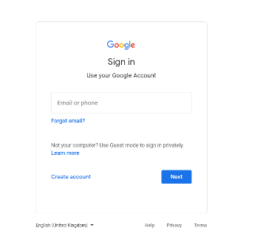
- Sign in to Google Classroom using the login details sent out by class teachers. If you do not have your child’s login details please contact the school office.

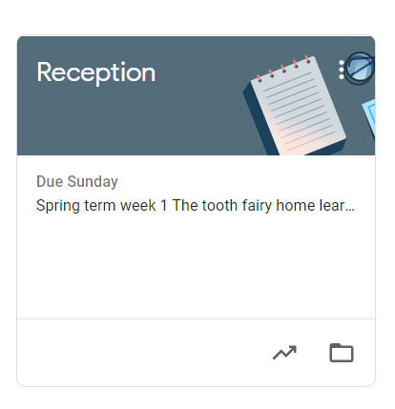

- Click on your child’s year group page e.g. Year One.

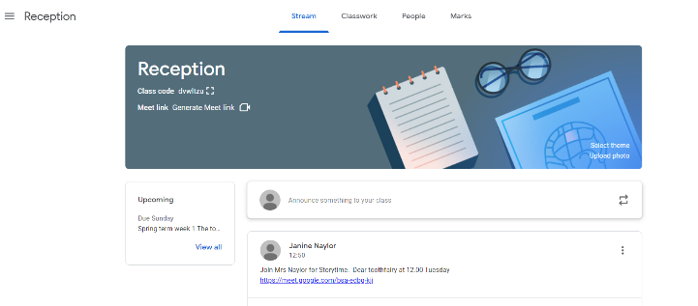
- To find the links for live lessons please click on stream and look at announcements.

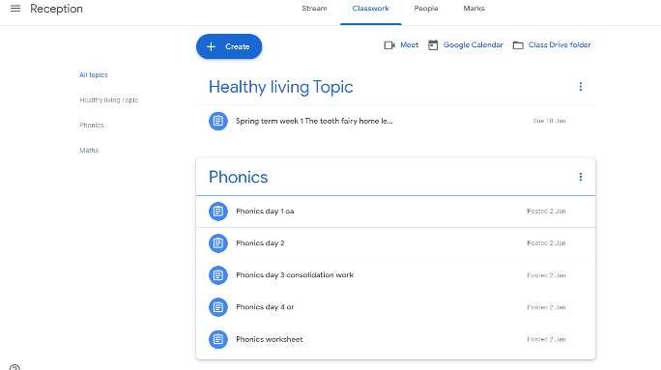
- To locate classwork and activities, please click on classwork.

