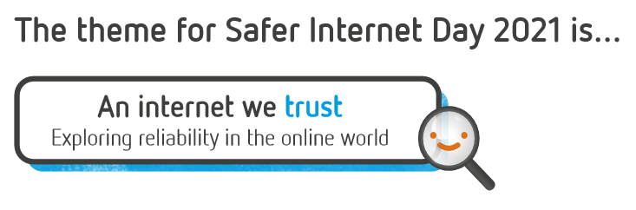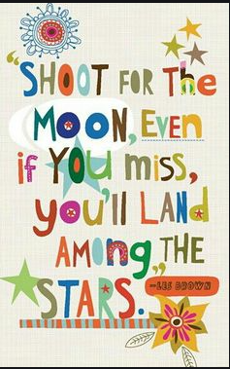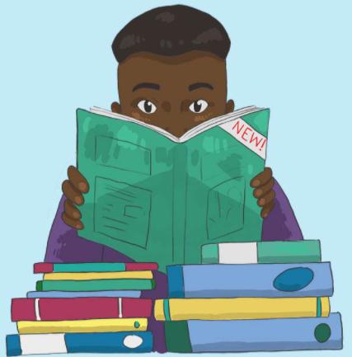

**How many books have you read?**

What books have you enjoyed reading lately?

It would be great to hear about books you think other people might enjoy.

Think about why you liked the book and share it with a friend.

Have you re-read a favourite book?

What was it and why is it your favourite? What types of books do you like reading the most?

Is it an adventure story? Is it a factual book?

Do the characters make you enjoy the book?

Is there pictures/illustrations you enjoying

looking at when reading books?

*What is Safer Internet Day?*

*Safer Internet Day is on 9th February 2021. It’s celebrated across the globe in over 170 countries, with thousands of young people joining in across the UK to explore how they can use the internet responsibly, respectfully, critically  and creatively. We are joining in and seizing this opportunity to focus on online safety and especially, the reliability of information online. You can also support your child by asking about what they like to do online or using their favourite app or game with them. You could support the day on social media, tell other friends and family about the day, or ask your child for their best tips for staying safe online.*

*Find out more here:*[*http://www.saferinternetday.org.uk*](http://www.saferinternetday.org.uk/)