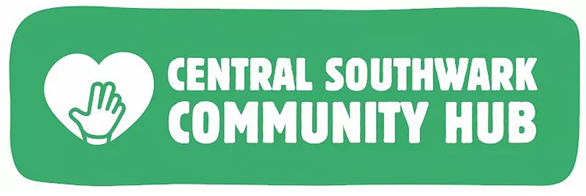
Hello,

We wanted to let you know that Spring Community Hub, formally Central Southwark Community Hub, will be running a free holiday club from 26th July - 26th August. We will be running eight centres across Southwark and one of these will be a SEN centre.

Our Holiday Club will run each week from Monday - Thursday, during which we will provide families with activities and lunch.

We will have arts & crafts, drama, workshops, storytelling & field trips every Thursday.

We are also planning two trips in the final week, one where we will take everyone to the seaside.

We would love it if you could spread the word about our holiday club, perhaps in your newsletter, as families can refer themselves to us.
We are also hoping you will be able to identify families in your school who would benefit from this support.

If you would like to refer a family to our Holiday Club, please send an email to holidayclub.csch@gmail.com or call 07988 138 997 with the following details:

- Parent name
- Parent contact number
- Number of children and their DOB

We look forward to hearing from you!

Best wishes,
Roisin

