Autumn 1- Romans
- Pick one task each week
- Spend around 30 minutes completing the task
- BE CREATIVE and use what you have learnt in class as well as what you have researched/learnt at home
Homework is given out on Friday. Homework should be handed in by the following Tuesday.
Create a timeline of the key events during the Romans. Choose 2 to talk about in detail.  Steps to success:  - Have you included keys facts about Roman culture?  - Have you neatly presented your timeline?  Challenge:  Can you compare aspects of Roman life to your life now? | What did a soldier in the Roman times look like?  Use collage techniques to create a collage picture of a soldier in the Roman times.  Steps to success:  - Have you got a clear outline of a soldier’s uniform?  - Have you used tearing and cutting to create different shapes and sizes to fit into the collage?  Challenge:  Can you create a 3D effect to your collage? | Choose an influential person during the period of the Romans, create a character profile about them.  Steps to success:  - Have you used a variety of sentence starters?  - Have you used ambitious adjectives to describe their features?  Challenge:  Can you include descriptions of why they were important during the Roman times?
Roman adventure.  Can you write a story as a child who was transported to the Roman period? What happens, how do they feel?  Steps to success:  - Has your story got a beginning, build-up, problem and resolution?  - Have you included adjectives to build description?  Challenge:  Can you include sentences which use a fronted adverbial? | 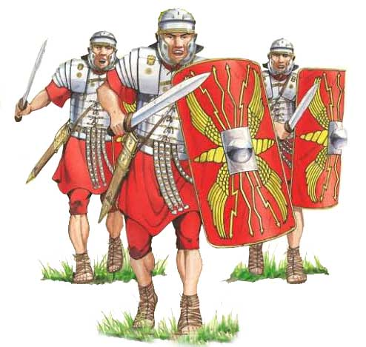 | Create a diagram or model of a Roman shield.  Steps to success:  - Have you created the detail on the front of the shield?  - Have you clearly labelled the different parts of your shield?  Challenge:  Find out about why Roman’s shields are designed in that way. Why are they that shape? Why do they have that design on the front?
Create an information poster about the must know facts about the Romans. Think about the dates that they were around, who was in charge, and how they took over. Present this in any way that you want.  Steps to success:  - Have you used extended noun phrases?  - Have you used engaging pictures in your poster?  Challenge:  Can you include some did you know facts? | What type of food did they eat during the Roman period?  Create a menu of the types of food a typical Roman would eat during that time.  Steps to success:  - Have you included the different times of the day each meal would be consumed?  - Have you explained what the meal is called?  Challenge:  Can you explain whether you would want to eat any of the meal they ate and why? | Make a presentation of the similarities and differences between modern day Rome/Italy and it during the reign of the Romans? (Think about how people live, government, religion, dress, food etc.)  Steps to success:  - Have you written the information you found in your own words?  - Have you used contrasting conjunctions to help you compare?  Challenge:  Can you explain which period of time you would rather live in?
REMEMBER:
- Only use pencils in your homework books. No felt-tips or pens.
- Don’t forget to read every day.
- Please present your work as we expect in school - neat hand-writing and taking care with spellings and punctuation.

