Curriculum Intent
Handbook

EYFS, Key Stage 1 and Key Stage 2

Contents

SECTION 1: Overarching Intention

Aims and Objectives of Oliver Goldsmith Curriculum | p.2
Rational – Our Approach to Curriculum Design | p.3
The Extended Curriculum and Cultural Capital | p.4
SECTION 2: Whole School and Subject Specific Intentions

Whole School Overview – Year Group Topics | p.5
Structure of Topic Based Learning – KS1 and KS2 | p.8
Structure of Topic Based Learning – EYFS | p.19
Reading – Phonics, Daily Supported Reading & Destination Reader | p.14
Spelling, Punctuation and Grammar | p.16
Handwriting | p.17
Maths – Maths Mastery and White Rose Maths | p.18
Science | p.19
Computing | p.20
PSHEE | p.21
Music | p.22
Modern Foreign Language: Spanish | p.23
PE | p.24
RE | p.25
SECTION 3: Logistics and Organisation

Weekly Expectations | p.26
A Typical Day | p.28
After School Clubs – Enrichment | p.30
SECTION 4: Evidencing the Impact of our Intention

Measuring the Impact of the Curriculum | p.31
Expectations of Children’s Outcomes | p.32
Assessment Procedures and Measures | p.34

SECTION 1: OVERARCHING CURRICULUM INTENTENTION

Aims and Objectives of the Oliver Goldsmith Curriculum
Aim of our Curriculum:
The aim of our curriculum is to engage every child in a relevant and interesting curriculum. We believe as educators that the curriculum should be aspirational, purposeful and inclusive, to ensure that all children develop a sense of curiosity and identity in the world around them. A progressive curriculum offers the chance for every individual child to access learning at their level by building on previous knowledge and skills. Each child should be challenged and inspired through a rich curriculum to ensure that they are motivated to achieve their best in preparation for the next key stage.

Objectives of our Curriculum:
- To provide a curriculum that facilitates opportunities for every child to access a broad and balanced curriculum that encompasses all objectives of the National Curriculum and beyond.
- To develop all children’s aspiration, confidence, independence and self-motivation relevant to life in modern Britain.
- To engage pupils in learning that promotes depth and a richer understanding of the world - past, present and future.
- To underpin reading, writing and speaking and listening skills across the curriculum in a variety of contexts for a range of purposes.
- To challenge and support every child so that they reach their potential or National academic benchmarks and are well prepared for the next key stage.

Rational – Our Approach to Curriculum Design
EYFS:
The intent of the EYFS curriculum is to ensure that the whole child develops and achieves their full potential. Children will leave the EYFS ready for formal learning in Key Stage 1 and will have acquired the necessary skills to be successful. Throughout the EYFS children’s learning and welfare are the main priority, ensuring that teaching is differentiated appropriately to meet all the learners’ needs, providing appropriate challenge.
In response to identified need from annual baseline assessments, the priority for Oliver Goldsmith Primary School is to ensure that our pupils develop their early language skills. These have a major impact on the development of literacy skills later in a pupils’ education. Strong early language skills give children the essential foundation for learning in primary school.
There is strong evidence that good quality early education has a positive impact on children’s future learning, including their language skills. It is the aim of Oliver Goldsmith Primary School to ensure that pupils leave the EYFS with at least a Good Level of Development. To ensure that children can achieve this, the curriculum is planned to be broad, engaging and exciting. Communication and Language is at the heart of the curriculum as early language skills have an enormous impact on children’s ability to access and express their learning in later years.
The curriculum is structured to provide opportunities for child initiated and adult directed activities. Adult led activities can be 1:1, in small groups or whole class. We promote children to learn something new and apply this learned skill in ways that are freely chosen.
Key Stage 1 and Key Stage 2:
Our curriculum encompasses a balance of subjects that are taught in isolation and subjects that are linked together into topics.
Isolated Teaching Subjects: | Topic Based Learning Subjects:
- Literacy (Reading)  - Maths  - Science  - RE  - PSHE  - Music  - Spanish  - PE  - Spelling Punctuation and Grammar  - Handwriting  - Computing (Computer Science) | - Literacy (Speaking, Listening & Writing)  - History  - Geography  - Art  - DT  - Computing (ICT and Digital Literacy)

Oliver Goldsmith has taken this approach to the curriculum so that:
- Every child can be immersed within a topic relevant to the world around them, enabling strong links that allows breadth of exploration of engaging themes, concepts, knowledge and skills.
- The learning that takes places across each half term, year group and key stage can be progressive and children are given the chance to apply previous learning in a more dynamic and tangible manner.
- Children can use and apply the skills developed within each subject area to enhance written outcomes and oral discussions.
- Learning time is maximised in order for every child to experience each subject more regularly within the Primary National Curriculum.
- Specialist teachers are able to deliver individual subjects – ensuring that each child receives high quality teaching across all subject areas. Children currently have access to a Spanish, Music, Art and ICT specialist teacher.
The Extended Curriculum and Cultural Capital
As well as providing children with a broad and balanced curriculum, we believe in extending every child’s opportunity through the extended curriculum. This includes providing opportunities for developing the ‘whole-child’ and the role they play in the next generation.

In addition to the full curriculum coverage through isolated subjects and topic based learning, each half term lends itself to a theme, which can be applied across the curriculum; support PSHE and circle times; and provide a focus for weekly assemblies:
Autumn 1: | Spring 1: | Summer 1:
Diversity | Problem Solving | Our Future
Autumn 2: | Spring 2: | Summer 2:
Keeping Safe | Citizenship | Transition

Supporting the Community, the Country and the World:
Throughout the year our school supports charities through fundraising. Across the year, a local, national and international charity is chosen so children within the school are given a chance to be a citizen and learn further about issues that affect those near and far. Money is raised through dress-up days, performances, donations and sponsored events. Through circle-times, assemblies and PSHE lessons, children learn about the chosen charities, the work they do to help others and how their donations make a difference. School Council also promotes this aspect of school life across the whole school.

Educational Visits:
Throughout each topic, teachers plan for a variety of enriching opportunities that stem beyond classroom lessons. It is the expectation that each topic would contain an opportunity for a least one of the following:
- An immersive experience that links directly to the topic that is being taught (a ‘Wow’ Day)
- A trip to a museum/ attraction/ theatre/ gallery/ place of historical interest/ geographical site visit
- Inviting an expert or professional visitor/ speaker/ performance/ author/ historian into the school
The school also provides opportunities for an extended visit to further enhance children’s opportunities and experiences.
In Year 6, children have the opportunity to visit PGL, which provides children with the chance to further enhance their outdoor and adventure skills over three days. This trip allows children to use specialist equipment and to experience the outdoors. Also, this residential activity centre facilitates children to be able to develop many key skills, such as team-work, communication, risk taking and problem solving. This trip also promotes their personal development and independence.

SECTION 2: WHOLE SCHOOL AND SUBJECT SPECIFIC INTENTION

Whole School Overview – Year Group Topics
Early Years Foundation Stage: CHECK
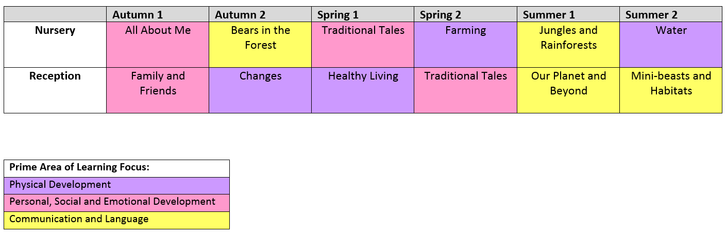
The topics that have been selected, cover a broad range of vocabulary and enhance children’s understanding of the world around them, giving them the cultural capital that they need to be successful in the rest of their education. The EYFS Curriculum is progressive, starting with vocabulary linked to the children themselves, their immediate family and personal experiences. Throughout Nursery and into Reception the topics promote a range of different language and experience. The children have access to a stimulating environment which offers a range of activities which encourage children’s interest and curiosity both indoors and outdoors. Learning occurs through first-hand experiences that encourage exploration, experimentation, observation, problem solving, prediction, critical thinking, decision making, and discussion.
Each EYFS topic has an overarching prime area of learning focus. Vocabulary and facts that children learn are directly related to the theme. Units are structured around core texts, with the ‘Book of the Week’ at the heart of every activity. Through this, the children learn a vast variety of language and specific nuances of language from fiction, poetry and non-fiction texts. At the beginning of the week, there is a ‘hook’ to fully engage and interest the children; the children are then immersed in the text, through planned adult focus activities and independent enhanced provision within the indoor and outdoor environments. Planned adult directed activities include drama and talk to support understanding of the text and to develop vocabulary, language and ideas for writing. It is through this wonderful book based curriculum that the children develop a love of reading.
Observations are the key to understanding young children as learners and a vital tool in finding out more about them as individuals. It is an integral part of the assessment and planning cycle and a firm basis for reflection. Staff observe children's actions, expressions, gestures and behaviours, and listen to their talk and interactions. Observations are printed and kept in Learning Profiles for each child, this allows the children to look at their profile and review their learning over the year. Parents/carers are invited to come and read their child’s profile with them to develop links between home and school. Teachers review the children’s observations and make assessments about each child’s stage of development, from this they set the children targets for each aspect of learning.
For our youngest children in Nursery, the prime areas of learning are at the centre of the curriculum. Children with a secure foundation in Personal, Social and Emotional Development, Physical Development and Communication and Language will be ready to learn the specific aspects of learning as they move through the Early Years.
At Oliver Goldsmith Primary School we offer full time places for all pupils in Nursery. Research has shown that attending an early years setting can help to improve children’s outcomes and narrow the gap associated with socio-economic disadvantage. Researchers saw beneficial outcomes for children associated with higher amounts of childcare for both disadvantaged and other children. Due to this research and our experience with young pupils we fund full time places for all our pupils, even if they are not eligible for the 30 hours free childcare. Therefore doubling the allowance from the original 15 hours for many of our pupils. Attending nursery widens children’s experience of the world. Taking part in different activities, spending time with different children and adults and visiting different places helps their confidence to grow and build a foundation which prepares them for life in the outside world. As the nurseries are attached to the schools, share the same site and some of the same facilities it is an excellent way to make starting school easier. The children are familiar with the school, teaching styles, learning environments and the daily routines, which makes transition to Reception easier for them.
In order to support a smooth transition for children who did not attend our Nursery, teachers visit feeder nurseries in the local area and meet the children. All new children are offered a stay and play session, where they can come into Reception with a family member, to explore the learning environment. Home visits were undertaken [pre COVID] as we recognise that these visits build relationships between school and home and enable parents/carers to share their knowledge of their child’s interests and abilities. They also provide an opportunity for parents to discuss and ask questions related to their child’s development in a private environment as well as ask questions about school policies. Children really appreciate the fact that the teacher or their key person has visited their home.
The topics in Reception are progressive and build on what children have learned in Nursery. There are opportunities to recap and review key concepts or facts and for children to make links to their previous learning. Children benefit from meaningful learning across the curriculum. The learning environment supports the intent of the curriculum. Resources are chosen to meet the children’s needs and promote learning, allowing children to experience awe and wonder through their play.
In Reception, each half term has an overarching theme. Each Topic is be broken into 2 weekly cycles. Week 1 primarily focuses on Fiction texts. Through planning around a high quality text, children learn patterns of language, vocabulary and will develop an understanding of narrative. Literacy outcomes will focus on specific links to the text (generally fiction outcomes). Week 2 builds on the learning from week 1 but in a more factual way. Allowing children to relate the text to real life. Children will learn knowledge and skills that relate to the world and their lives. Literacy outcomes will generally focus on non-fiction genres.
KS1 and KS2 Curriculum Topics:
 | Autumn 1 | Autumn 2 | Spring 1 | Spring 2 | Summer 1 | Summer 2
Year 1 | Amazing Africa | Ourselves-making history | Queen Elizabeth II | Into the Woods | Now and Then | Island Life
Year 2 | Journeys Around Great Britain | Arctic and Antarctica | The Great Fire of London | South America | Nocturnal animals/habitats | Our Local community
Year 3 | Kenya | Stone Age | Asia | Tudors | Disaster strikes | Tomb Raiders
Year 4 | Through the Ages: Romans | The Shang Dynasty | United Kingdom | Here come the Vikings | Saving Planet Earth | Amazonia
Year 5 | Blast Off! | North America | Mayan Civilisation | Remembering Heroes WW1 | Doctor, Doctor | Desert Survival
Year 6 | WW2 The Home Front | Europe | The Ancient Greek | Evolution | Diaspora | Water: Friend or Foe

Within each year group, topic focuses have been carefully allocated in order to take into consideration full coverage of each of the National Curriculum subjects that need to be covered. Each topic consists of one of the humanities subjects (History or Geography), as well as linking either Art or DT. The following aspects of learning are broadly covered in each year group’s curriculum:
- History: A specified period of history; and a historical monarch.
- Geography: A link to the UK; and a continent of the world
- Art: A period, a movement, a famous artist, a famous piece of artwork; a medium
- DT: A material; a design brief; a resource (Food, Textiles, Resistant Material)
- Computing: A coding program; a device; a multi-media software
Each year group also has one topic that lends itself to a Science unit of work making this an opportunity to broaden children’s Science curriculum from the isolated lesson that are taught every week.
It is the expectation that Literacy will underpin each topic, including development of Speaking and Listening skills, Reading skills and Writing skills across a range of fiction, non-fiction and poetry.

Underpinning Themes:
Throughout the course of the children’s journey through the topics, the children get the opportunity to encounter underpinning themes throughout all of the topics:
- History: Legacy; Leadership;
- Geography: People and Place; Global Citizenship; Change.
- Science: Scientific Phenomenon; The Natural World; Science in the Real World; Scientific Future

Structure of Topic-Based Learning – Key Stage 1 and Key Stage 2:
The benefit of children working within a current topic means that they can gain knowledge and skills across a variety of subject areas in order to assist them in remembering new information gathered. By immersing the children within a topic, this also supports with children engaging in what they are learning. By generating a wide knowledge base of a particular topic, we believe this supports children in generating compositional ideas for writing outcomes. Therefore, the expectation for each topic is that the first section of the topic is using the foundation subjects to acquire a depth of knowledge and understanding. Once this has been established, a block of writing opportunities can be given to children in order to begin the writing process of drafting, editing, developing and publishing outcomes across a range of purposes, writing intentions and narrative genres. Writing skills are also specifically taught to establish a solid knowledge of writing skills.
- Developing Knowledge and Skills of Topic | - Application and Writing Knowledge and Skills
Knowledge and skills of Foundation Subjects:  - History or Geography knowledge and skills are taught in order to give an understanding of time or place.  - Art or DT skills are explored to provide children with a creative sequence and outcome in each topic  - A Literacy skill (Reading/ Writing/ S&L) to be embedded in every lesson. | Writing Workshops:  - Topic lessons focus on the process of writing, building up the skills to an extended piece of fiction/non-fiction/ poetry writing (two per topic).  - Children to apply their understanding of the topic within each piece of writing.  - Children to be taught the writing process – including drafting, editing, extending re-drafting etc.  - Children to publish one of the pieces of writing.
Each child would have fully explored their topic through a historical, a geographical or a scientific lens – drawing upon a wide range of Literacy skills to understand, express, explain or perform their understanding. Within the first section of a topic, children will follow:
Science:
Week 1: What are the main concepts and what do we need to know?
Week 2: How can we inquire into this scientific concept – processes and methods?
Week 3: How does this Science effect today’s world?
Week 4: How can we apply what we know to think about the future?

History:
Week 1: When did this happen?
Week 2: What was life like then?
Week 3: What effect did it have at the time?
Week 4: How did this period of time effect today’s world?

Geography:
Week 1: Where in the world are we learning?
Week 2: What are the physical features of this location?
Week 3: How does this effect the human geography within this location?
Week 4: What are the similarities and differences between this location and our location?

Children are then expected to apply this understanding through being taught and given the opportunity to apply their understanding in two written outcomes – either fiction, non-fiction or poetry. By the time children have progressed through the school, they would have covered a full range of different genres – building on complexity in language, sentence types and overall compositional structures. Work completed in isolated Reading sessions and SPAG lessons are also applied and drawn upon to provide children the best chance to produce the best possible writing outcomes.
Structure of EYFS Learning:
Oliver Goldsmith Primary School applies the DfE Guidance - Development Matters as the basis for the structure of learning. Within this document, it outlines the following ‘Characteristics of Effective Learning’ and the ‘Seven Areas of Learning’ that is used to underpin the EYFS curriculum:
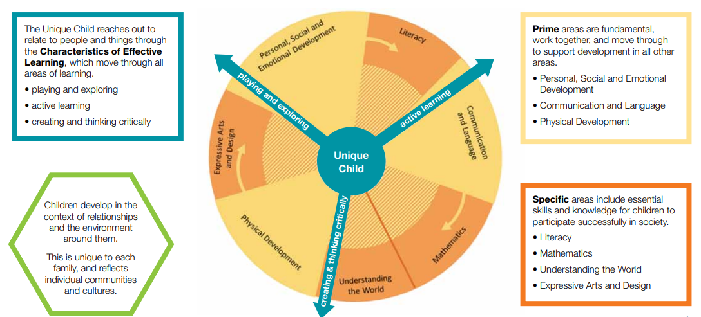

The schools adopt a play based curriculum. This is in line with how children learn and outlined as best practice within ‘Development Matters in the Early Years Foundation Stage’ (2012). Learning activities, such as creative arts, literacy, maths, social skills and scientific inquiry. are presented to children through play. The staff encourage children to play, facilitating both social and emotional skills. Play enhances children’s physical, social/emotional, and creative growth and development. It is the primary means by which children explore their world and begin to make sense of the world around them.
The play-based learning environment in our schools are set up in sections. There are areas for reading, writing, role-play, water play, building, and maths. These areas of learning incorporate play-based materials and activities that the children find engaging. The learning environment is inspiring, stimulating, and nurturing, and welcomes all children of cultural, ethnic, and linguistic backgrounds.

At the schools we provide children with the opportunity to explore ‘real’ objects, which helps them to create their own learning and pose questions they can answer. Photographs and models require children to draw on prior learning in order to answer questions. Real objects allow for freer discovery and for the children to be involved. Examples of this in the setting include, real food in the role-play area and real money to count. By giving children a real object over a picture or pretend one, children are encouraged to use all of their senses to find out about that one item. Consequently, the learning opportunities are far greater.

Areas of Learning:
- Communication and Language
The EYFS staff ensure that pupils have positive relationships with adults. During interactions with children they encourage the pupils to respond to eye contact, verbal and non-verbal interactions. The children learn to anticipate and initiate communication with others and to respond in a variety of ways. Children learn this through listening to adults, other children, watching and imitating them and through joining in with rhymes, stories and games using sounds and words. In this way they learn to attend to important features of communication and to respond, eventually being able to divide their attention between what is being said and what they are doing.
The curriculum allows children to hear language being used, to talk about things they can see and feel, what they have just experienced or are about to experience, what they are curious about and what they care about. This is the type of speech that provides children with the raw material they need to learn a language - to figure out what words mean, where a subject or a direct object fits into a sentence, how to ask a question, and all the other aspects of language.
It is fundamental that children develop effective comprehension of what has been said to them. Through scheduled time for dialogue between adults and children, they learn how to become an effective communicator. They learn that sharing talk with others is all part of the communication process. In this aspect of communication and language, children show understanding in many ways, including responding following instructions and responding to and asking questions to check out meaning. Every experience a child has extends their understanding and the adults at Oliver Goldsmith Primary School support them through sharing the experience and helping them to process and apply the experiences with growing independence.
It is our goal through the curriculum that the store of words that children have will increase enormously and this helps them to be effective and skilful communicators. With help from skilled practitioners, and through hearing correct language the children will internalise the rules of grammar, which is fundamental to becoming an effective writer in later life. The children develop ways to express themselves based on their own ideas and experiences.
In order for pupils to learn a range of language in the EYFS classrooms, silence is not golden. Spoken words are opportunities for learning that should take place throughout the day - especially during conversations between children and between adults and children. Language - with all of its magnificent complexity - is one of the greatest gifts we give our children. Language acquisition is a product of active, repetitive, and complex learning. The staff help children learn language primarily by talking with them. The curriculum overview includes specific topic vocabulary that will be built upon in Key Stage 1 and beyond. Staff will use this language in play based activities in order to support the children to acquire the language and gain a true understanding of the words meaning within a context.

When it is identified that a pupil has a communication delay, speech and language interventions will be planned and delivered several times per week. For pupils who need additional support with language acquisition, the EYFS staff work closely with a Speech and Language Therapist to set targets, undertake intervention and then review children’s progress at meeting those targets.

- Physical Development
Good physical health is promoted consistently throughout the curriculum. Staff give clear messages to children about why it is important to eat, drink, rest, exercise and be kind to each other. They teach children to take managed risks and challenges as they play and learn, supporting them to be active and develop physically. This is achieved through the children’s access to a stimulating and exciting outdoor environment. Planned activities outdoors involve the children moving their bodies in different ways and recognising the impact of exercise on their body. When children start in Nursery they learn to develop their gross motor skills by climbing, running and jumping. They are then supported to develop their fine motor skills, through a range of activities, including threading, moulding playdough or cutting with scissors. Ultimately by the end of the EYFS the children will be holding a pencil with a tripod grip and forming letters correctly.

Healthy lifestyles are actively promoted through specific termly topics and during daily focus activities. Children have the opportunity to cook a range of healthy recipes and learn about good practices with relation to hygiene when preparing food. Snack tables in each classroom support the children to become independent in managing their own physical needs. Children leave the EYFS with a good understanding of the importance of living healthy lives and they actively make healthy choices.
- Personal, Social, and Emotional Development
A positive relationship with staff and the children begins when the children are settling into Oliver Goldsmith Primary School Through an induction meeting with parents/carers, a stay and play session, a home visit and a slow staggered entry into EYFS, the children and families develop their confidence in our setting. We endeavour to ensure that the children feel secure. The key to this is creating a nurturing environment and the staff get to know each child personally through having an effective key person.
PSED is embedded in all aspects of the EYFS, rather than being taught in isolation. The staff model appropriate behaviour and respond to incidences within the environment when they occur. Through the Traditional Tales topic, the children learn about morals and how to apply these lessons to their lives. Turn taking and sharing are fostered through small group activities with adults, the children learn to apply these skills independently over time.
Routines reassure children as they begin to understand the structure of the day and can predict what is coming next. This helps to reduce anxiety for children. Furthermore, visual timetables are used to support children who aren't able to understand verbal prompts yet.
Children learn to recognise their feelings and learn the words to label them. They are supported by staff to learn different ways to manage their feelings. By the end of Reception the children will be emotionally literate, have an understanding of what is right/wrong and why. They transition into Key Stage 1 with confidence and are prepared to achieve all the challenges of the Year 1 curriculum.
- Literacy Development
Children in Oliver Goldsmith are exposed to a wide variety of high quality texts. These include, fiction, a range of non-fiction genres and poetry. The staff read to children daily during whole class shared reading sessions. The children learn to enjoy, listen attentively and respond with comprehension to familiar stories, rhymes and songs that are appropriate to their age and stage of development.
Planning for the learning environment is closely linked to the themes within the book of the week. Children are exposed to topic vocabulary and learn to recognise key words within the text. Opportunities for mark making and writing are included in every area of the indoor/outdoor environment, such as clipboards to design and label buildings in the construction area. Children are encouraged to record their learning outdoors with large chalks, big paintbrushes and water or clipboards. This allows the children to write for a range of purposes and develop their gross motor movements and understanding of letter formation. Writing/mark making areas are exceptionally well resourced with a range of mark making tools to encourage pupils to experiment with their phonics and independent writing. Key words, letters, digraphs and high frequency words are displayed in order to promote children to read and use these words in their own writing.
Displays within the classroom include children’s writing at their stage of development. Throughout the print rich environment there is a balance between handwritten words and printed letters, this allows pupils to recognise the relationship between reading and writing. Book corners are highly stimulating and linked to a core text and give the children the opportunity to interact with a wide variety of books. The areas are comfortable and have a welcoming atmosphere, which encourages pupils to develop their library skills. Story sacks are provided so that the children can re-enact a story, using a storyteller’s voice. Staff spend time each week modelling how to use the book corner and the children develop their skills in how to select a book which they will enjoy.
Children have the opportunity to take reading books home at an instructional reading level which is closely matched to the phonics they are learning in school. Children also have access to a wide range of books they can read for pleasure. Books are changed regularly and parents/carers are encouraged to keep a diary of their child’s reading at home. The partnership between reading at home and school is further fostered during weekly family morning sessions.
Literacy skills are embedded in the curriculum and by the end of Reception, children are confident at applying their Phase Three phonics knowledge and achieve early learning goals for reading and writing.

- Mathematical Development
Mathematics is an important part of learning for all children in the early years and receiving a good grounding in maths is an essential life skill. As well as numeracy, it helps skills such as problem solving, understanding and using shapes and measure and developing their own spatial awareness. It helps children to recognise, create and describe patterns, which is essential for early problem solving skills. At Oliver Goldsmith Primary School, maths is introduced to children when they start Nursery. Children develop their understanding of all elements of problem solving and reasoning in a broad range of real world contexts.
Maths areas within the classroom provide a space for children to play and explore with the maths resources. Key resources include: counting objects, cubes, hoops, numbers, shapes, challenges, clocks, timers, puzzles and games. Maths lends itself particularly to being discovered and understood with the hands. Staff plan for children to learn maths in a very practical way. Children learn to count objects reliably not through rote counting, but by the physical picking up and moving of objects, consolidating 1:1 correspondence and understanding the concept of quantity as they do so. The maths areas allow for plenty of open-ended, self-directed maths play. Adults ensure that they spend time modelling counting behaviours with children in small groups and plan investigations for children to problem solve solutions. In addition to the specific maths area, the entire environment is set up with aspects of mathematical learning such as, funnels and jugs in the water tray to explore capacity.
Maths carpet sessions are taught daily covering all of the objectives within EYFS by the end of Reception. Staff assess children’s understanding and support individual pupils through targeted groups to repeat/further explain concepts. Children leave the EYFS with early learning goals in Number and Shape, Space and Measures. They also have an understanding of abstract maths in preparation for year 1.

- Understanding the World
Understanding of the World is about how children get to know about other people, the place where they live and about all aspects of the environment. Baseline assessments show that some pupils come into Oliver Goldsmith Primary School with limited experiences of the world. The curriculum is designed to inspire the children and give them a sense of belonging to the school community. The daily routine allows children enough time to become engrossed in an activity and to explore and investigate how and why things work and to test out their ideas of what will happen if they do a particular thing like pouring more and more sand into a container, for example.
The curriculum is built on children developing an awareness of themselves and their families from the autumn term. As children learn about the world around them they find out and learn about how other people are different from them, yet share some of the same characteristics and ideas. Ultimately when children leave the EYFS they are respectful of different beliefs, traditions, cultures and communities.
Understanding of the world develops as children take notice of everything around them including places and all the things within them such as, plants in the EYFS garden. Children are supported to observe the seasonal changes and how the environment adapts throughout the year. The focus of the curriculum is to develop children’s understanding of the local area and then build their awareness of the wider world including different habitats around the globe. This awareness is extended by school trips and local area visits.
Technology has become commonplace and children often see and use it quite naturally. The curriculum teaches children to recognise the role of technology and how they can use it for a range of purposes.

- Expressive Arts and Design
It is the aim of the curriculum to develop children's imagination, creativity and their ability to use media and materials. Children achieve this in range of ways including singing songs and making music, dancing, playing with colours, textures and design. All these approaches to expressive arts help children to represent and understand their own feelings and ideas. Staff ensure that there are no templates to limit children’s creative expression. Different focus activities are planned to allow children to experiment with media and materials finding out about their properties and modifying and manipulating them. They include exploring sounds, patterns, movement and different tools and techniques.
Role-play and narrative language is an important skill when children are older to allow them to become creative writers. In the EYFS, the children are taught to become involved in the world of pretend, building on their experiences of the real world and transforming them into something new – whether through role play, music, pretend play, block play or small world play or a range of other areas. The children are exposed to rich vocabulary and learn to use this independently in their play.
The staff help children to be creative by encouraging attitudes of curiosity and questioning about skills or techniques. Children notice everything and closely observe what adults do. Building on children’s interests and fascinations can lead to them creating amazing inventions or making marks on paper that represent for them an experience or something they have seen. The children will use creative expression to demonstrate their knowledge about each topic. Staff encourage children to choose and use materials and resources in an open-ended way and help them to make choices and to have confidence in their own ideas. Retaining childhood confidence in their ideas and skills can easily be lost if others ‘take over’ and try to suggest what the child is making, thinking or doing. To ensure that the children continue to have creative minds, staff express an interest in the process a child has gone through and ask open questions.

Reading – Phonics, Daily Supported Reading & Destination Reader
Phonics
The school believes that a systematic approach to phonics is essential in allowing every child to become and effective reader. From Nursery to Year 2, the children follow the DfE suggested programme of Letters and Sounds to ensure that progression across these years groups allow children to make rapid progress.
Nursery: Phase 1
Reception: Phase 2, 3 and 4
Year 1: Phase 5
Year 2: Phase 6
Daily phonics sessions in Reception introduce three new sounds a week. In Year 1 children learn four new sounds a week and alternative pronunciations of previously learned graphemes. In Year 2 the children learn about the past tense and how to add suffixes. A range of resources are used to support children’s learning to Revisit, Review, Teach, Practice and Apply each sound as they progress through the phases. By the end of year 2, children read with increasing fluency.
Key Stage 1: Daily Supported Reading (DSR)
Daily Supported Reading (DSR) is a quality first teaching programme that ensures sustained independent reading opportunities for all children in Year 1. Each child in the programme receives a daily reading session at their instructional level, taught by a teacher or a trained adult.
A key principle that defines DSR is ensuring early intervention. This approach to reading entails strategic deployment of adults from across the school to run DSR in Year 1 and into Year 2 for children that still need it. DSR also starts on a smaller scale in the final term of the Reception year as part of the transition programme into Year 1. The programme allows all Key Stage 1 children to have daily opportunities to read independently and in small groups. Most importantly, children are able to read at an appropriate level and to a well-trained adult. This early intervention in Year 1 means that all children are able to make rapid progress, before the gap is too wide. It also means that any child who is struggling, can be identified and targeted in order to overcome any barriers.
The aims of DSR Programme are:
- To dramatically increase the quantity of texts that beginner readers engage with enjoyably and independently every day.
- To ensure that all children make good progress by working with a trained adult in small groups every day.
- To establish a coherent approach to early reading instruction in KS1.
- To increase the quantity and challenge of texts across the year that children access, whilst still enjoying daily independent reading in small groups.
- To enable children to learn to solve problems within texts independently, while keeping a story or message in mind.
The key features of the DSR programme:
- Quantity of Reading: Children read up to 70+ texts across a year pitched to each child’s independent reading level.
- A Gradient of Difficulty: Adults learn to move children on. Lesson prompts/scripts change as texts get harder.
- Prompting: Children are required to monitor their reading and are prompted to notice errors and correct them independently.
- Comprehension: Lesson prompts/ Scripts link language that children use with that same language encoded in print. Children are taught to engage with and respond to text.
Children continue this approach into Year 2. Throughout Year 2, children continue to embed the mechanics of reading with focus on comprehension gradually increasing throughout the year.
Key Stage 2: Destination Reader (DR)
Destination Reader is an approach to teaching reading in Key Stage 2 that builds on DSR by focusing on comprehension rather than fluency. It involves daily sessions incorporating whole class modelling prior to the children applying these skills through partner and independent reading. Children deeper their understanding of the texts they read through the systematic use of a series of strategies and language stems.
The approach encompasses the key principles of effective reading provision and fully meets the requirements of the National Curriculum. It also builds a culture of reading for pleasure and purpose. Destination Reader dramatically improves children's reading, whilst making sure no one child is left behind. By developing a deeper understanding of what’s being read, Destination Reader actively engenders a love of reading which will endure throughout your children’s lives.
Destination Reader helps staff improve their effectiveness in the teaching of reading through the use of proven techniques. The programme draws on existing practice and research. An approach rather than a scheme, Destination Reader fits right in with the wider curriculum and favourite texts.

Home Reading Books:
- EYFS and KS1:
Children within these Key Stages are provided with two reading books to support their reading development. One book is matched carefully to the child’s ability in phonics from a systematic scheme that matches the phonics that the child is being taught in school in line with the phase from the Letters and Sounds programme. The second book enables children to start to gain an understanding of comprehension, vocabulary, including rhyme and poetry, book structures and story-telling. This book will enable to the children to read words they know or can phonetically sound out but also allow children to explore richer language and whole stories of a variety of publishers, prints and themes.

- Key Stage 2:
Children who have successfully completed the phonics programme and are confident in all the phases of Letters and Sounds and have built up their vocabulary appropriately are provided with reading books from a range of authors and publishers with themes suitable for their age groups. Children who need additional support in remembering the phonemes will still be provided with reading books that suit their level development. As children progress through Key Stage 2, it is an expectation that the books children are being asked to take home will develop in complexity of vocabulary, narrative structures, widening non-fiction genres and maturing themes and concepts. By the end of Year 6, we expect children to have read widely across a range of genres and authors – being able to discuss and explain their choices for the books they read. Home reading books are also matched to the topics that the children are learning in school, in order to support the development of knowledge across the curriculum.

Spelling, Punctuation and Grammar
In order for every child to be proficient in Literacy and Language, we ensure that children are committed to being exposed to a range of Spelling, Punctuation and Grammar opportunities across the school. This is an overview of what the typical expectation for each Year group is to cover across and throughout the year, both embedded during writing sessions and also through discrete teaching opportunities in SPAG lessons.

Teachers plan short, sharp and succinct spelling, punctuation and grammar lessons and activities that give children the chance to use and apply a range of rules, with their exceptions, to a range of purposes and functions. In order to engage children in this area of the curriculum, lessons are planned with games and activities that we know Mayflower children enjoy, such as quizzes, sorting and matching and ‘quick-fire’ questions.

SPAG lessons across Key Stage 2 are derived from progressive medium term plans, which have direct impact on writing opportunities within the curriculum topic allocated for that year group in the term. Children are taught these SPAGs skills directly with the expectation that they will be applied in the writing workshops in the latter part of the topic.

Handwriting
At Oliver Goldsmith, we are committed to ensuring that all children achieve the highest standards in all areas of the curriculum, including handwriting. Our aim for children’s handwriting from Nursery to Year 6 is to prepare them for the demands of secondary school and beyond. To achieve this, we ensure all children develop a confident and efficient handwriting style that fully supports them with their learning. All classrooms display the Lower Case and Upper case letters to model to children how to represent each letter.
Handwriting is a movement skill and needs to be developed throughout a child’s schooling. We regularly teach children to consistently form letters with the correct sequence of stokes is vital to produce confident and fluent writers. Fluent handwriting is key to children accessing higher level learning:
- Allows pupils to engage in quick note-taking.
- Confident and efficient handwriting is essential for essay writing and other demands.
- The more automatic the handwriting, the more children are able to focus on content.

Early Years:
In Nursery and the beginning of Reception, pre-writing / motor skills activities should be taking place daily in Nursery. Children to learn how to write their name and move onto phonics/letter formation. Children are taught and regularly practise pre-writing shapes. Handwriting is taught through focus group work where pupils begin to learn single letter formation.

In order to prepare children to write, gross and fine motor skills are important when developing good pre-writing skills. Children are encouraged to take part in large movement activities as well as fine motor activities.

In this stage of learning, children are encouraged to develop the correct pen grip and to pick up the pen/pencil near the point with thumb and index finger and swing the pen back into pen grip position.

Key Stage 1 Expectations:
Pupils’ writing during will generally develop at a slower pace than their reading. This is because they need to encode the sounds they hear in words (spelling skills), develop the physical skill needed for handwriting, and learn how to organise their ideas in writing. In writing, pupils should be able to form individual letters correctly, so establishing good handwriting habits from the beginning to support the move to joining is essential.

Key Stage 2 Expectations:
Joined handwriting should be the norm; pupils should be able to use it fast enough to keep pace with what they want to say. Pupils should be able to write down their ideas quickly. By the end of Year 6, pupils’ reading and writing should be sufficiently fluent and effortless for them to manage the general demands of the curriculum in Year 7.

Maths – Maths Mastery and White Rose Maths
The Essence of Maths Teaching for Mastery
Maths teaching for mastery enhances the idea that everyone can achieve in Maths. All pupils are encouraged by the belief that by working hard at Maths, they can succeed. All children are taught through whole-class interactive teaching, where the focus is on all pupils working together at a level that is right each individual child. This ensures that all children can master concepts in order to make rapid progress. Lessons are designed to identify new mathematical concepts through visual representations in a carefully planned learning journey. Maths lesson incorporate a range of activities, including back and forth interaction, questioning, partner work, short tasks, independent tasks. Reasoning skills are at the heart of Oliver Goldsmith’s Maths curriculum. All children experience procedural fluency and conceptual understanding in order to fully explore and understand a wide range of mathematical concepts, as outlined in the National Curriculum. Children are given the chance to practice mathematical skills, as a way of embedding learning and using and applying new skills in a variety of real-life contexts.
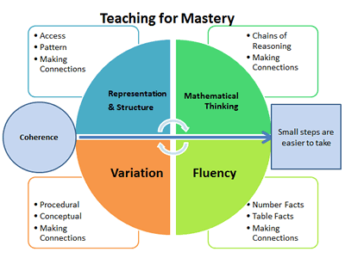
This diagram represents the model that teachers use to ensure a full breadth of mathematical strategies are used. Further to this, the Maths curriculum allows to children to address the following:
- Coherence:
Lessons are broken down into small connected steps that gradually unfold the concept, providing access for all children and leading to a generalisation of the concept and the ability to apply the concept to a range of contexts.
- Representation and Structure:
Representations used in lessons expose the mathematical structure being taught, the aim being that students can do the maths without recourse to the representation
- Mathematical Thinking:
If taught ideas are to be understood deeply, they must not merely be passively received but must be worked on by the student: thought about, reasoned with and discussed with others
- Fluency:
Quick and efficient recall of facts and procedures and the flexibility to move between different contexts and representations of mathematics
- Variation:
Variation is twofold. It is firstly about how the teacher represents the concept being taught, often in more than one way, to draw attention to critical aspects, and to develop deep and holistic understanding. It is also about the sequencing of the episodes, activities and exercises used within a lesson and follow up practice, paying attention to what is kept the same and what changes, to connect the mathematics and draw attention to mathematical relationships and structure.
Science
We believe that a high-quality science education provides the foundations for understanding the world through the specific disciplines of biology, chemistry and physics. Science has changed our lives and is vital to the world’s future prosperity that all pupils should be taught essential aspects of the knowledge, methods, processes and uses of science. Through building up a body of key foundational knowledge and concepts, we encourage each child to recognise the power of rational explanation and develop a sense of excitement and curiosity about natural phenomena. Children are encouraged to understand how science can be used to explain what is occurring, predict how things will behave, and analyse causes.
The National Curriculum provides the basis for our Science curriculum by describing a sequence of knowledge and concepts. While it is important that pupils make progress, it is also vitally important that they develop secure understanding of each key block of knowledge and concepts in order to progress to the next stage.
Within our science curriculum, pupils are taught to describe associated processes and key characteristics in common language. They are also familiarised with, and use, technical terminology accurately and precisely. Over time they build up an extended specialist vocabulary. Children are also given the chance to apply their mathematical knowledge to their understanding of science, including collecting, presenting and analysing data. The social and economic implications of science are important but are generally taught within the wider school curriculum. Teachers use different contexts to maximise their pupils’ motivation to study science. This is a list the current KS1 and KS2 Scientific topics are taught per half term, which should be cross referenced to the Topic Based Curriculum Map:
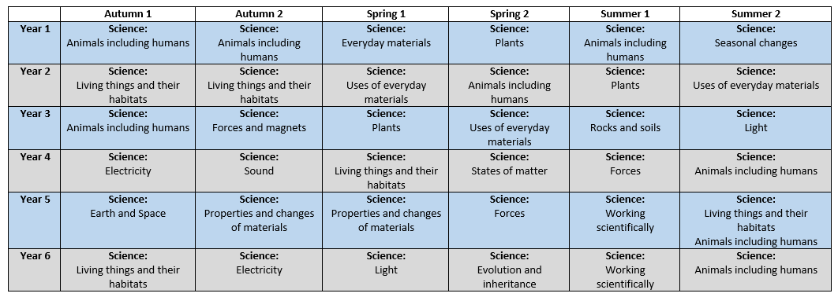

‘Working scientifically’ specifies the understanding of the nature, processes and methods of science for each year group and is underpinned throughout every topic. Medium term planning for science gives specific evidence of how ‘working scientifically’ is embedded within the content of biology, chemistry and physics, focusing on the key features of scientific enquiry, so that pupils learn to use a variety of approaches to answer relevant scientific questions. These types of scientific enquiry that are include within our curriculum are:
- Observing over time;
- Pattern Seeking;
- Identifying, Classifying and Grouping;
- Comparative and Fair Testing (controlled investigations);
- Researching using Secondary Sources.
Pupils are taught to seek answers to questions through collecting, analysing and presenting data.
Computing:
EYFS Objectives:
- Understanding the world involves guiding children to make sense of their physical world and their community through opportunities to explore, observe and find out about people, places, technology and the environment
- Expressive arts and design involves enabling children to explore and play with a wide range of media and materials, as well as providing opportunities and encouragement for sharing their thoughts, ideas and feelings through a variety of activities in art, music, movement, dance, role-play, and design and technology
Children are given access to a range of technology within the Early Years environment to be able to access these objectives. Teachers will ensure that children receive opportunities to embed the use of technology across the different topics – allowing children to explore how technology can be used in the world and also how technology can be used creatively.
KS1 & KS2 Curriculum Objectives:
Computer Science – Taught by a Specialist Teacher
KS1 | - Understand what algorithms are; how they are implemented as programs on digital devices; and that programs execute by following precise and unambiguous instructions  - Create and debug simple programs  - Use logical reasoning to predict the behaviour of simple programs
KS2 | - Design, write and debug programs that accomplish specific goals, including controlling or simulating physical systems; solve problems by decomposing them into smaller parts  - Use sequence, selection, and repetition in programs; work with variables and various forms of input and output  - Use logical reasoning to explain how some simple algorithms work and to detect and correct errors in algorithms and programs  - Understand computer networks including the internet; how they can provide multiple services, such as the world wide web; and the opportunities they offer for communication and collaboration

Information Technology – Included in Topic Based Learning
KS1 | - Use technology purposefully to create, organise, store, manipulate and retrieve digital content
KS2 | - Use search technologies effectively, appreciate how results are selected and ranked, and be discerning in evaluating digital content  - Select, use and combine a variety of software (including internet services) on a range of digital devices to design and create a range of programs, systems and content that accomplish given goals, including collecting, analysing, evaluating and presenting data and information

Digital Literacy – Included in Topic Based Learning
KS1 | - Recognise common uses of information technology beyond school  - Use technology safely and respectfully, keeping personal information private; identify where to go for help and support when they have concerns about content or contact on the internet or other online technologies.
KS2 | - Use technology safely, respectfully and responsibly; recognise acceptable/unacceptable behaviour; identify a range of ways to report concerns about content and contact.

Children in KS1 and KS2 have many opportunities to apply their computing knowledge across many different subject areas, as well as discrete learning opportunities. This includes topic work but also relevant links in Maths and Science are made to support the learning within these subject areas to deliver computing learning beyond that of the National Curriculum.
PSHEE (Personal, Social, Health and Economic Education):
We believe PSHE to be an integral part of our curriculum that allows children to understand themselves as people. It is only with a thorough understanding of ourselves that we can support children through the topical issues that they will come to experience as they grow up.
PSHE is taught in isolation and is taught for 60 mins per week, every two weeks or 30 mins per week.
This is the PSHE overview across Key Stage 1 and Key Stage 2:
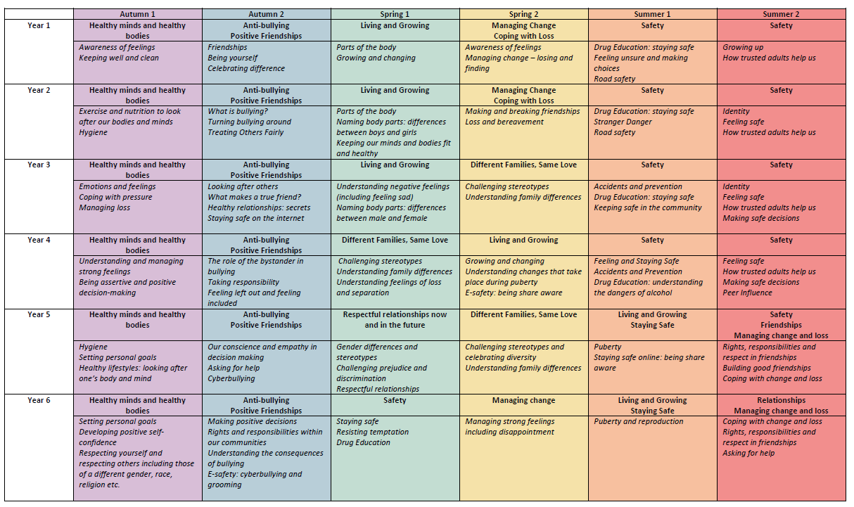

In addition to the overview, the following aspects of ‘Living in the Wider Community’ are also covered across each Key Stage, as well as through whole school assemblies, events and visits:
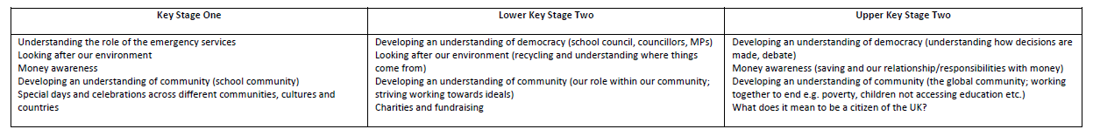

Music
Whole school assemblies and specialist music teachers are an addition to support the delivery of individual and class music. The music curriculum is designed to deliver the National Curriculum and whenever possible makes links to class topics. This is our overview of topics for the music curriculum:
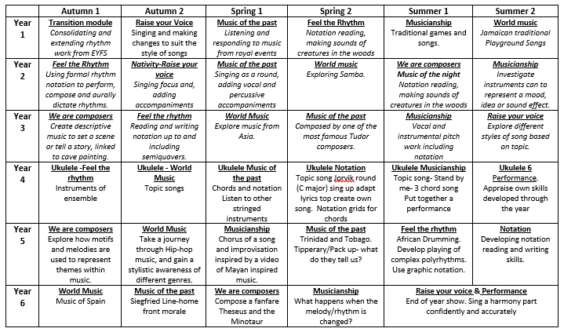
We believe that music is essential to life. Music increases listening and concentration skills and enhances our learners’ ability to discriminate between sounds. This in turn improves phonetic awareness and helps to develop language and literacy skills. It also has a positive impact on spatial reasoning, which is linked to mathematical thinking, and physical co-ordination, which supports handwriting skills. Music helps to develop our children’s short- and long-term memory, the ability to perform from visual signs and symbols, and the ability to listen with concentration. Playing an instrument extends these skills and develops co-ordination and control. We have a flourishing KS1 and KS2 choir, both of whom perform informally at school and more formally in venues
Singing: All year groups sing throughout the curriculum, weekly during singing practices and in our assemblies. The benefits of singing are numerous and far-reaching. It is healthy, promotes good breathing and posture, can make us feel better about ourselves, enhances our self-esteem and sense of well-being, it allows us to work collaboratively within groups in a non-competitive, highly supportive environment.

Children have quality opportunities to sing, play instruments, compose, appraise and listen to music. We encourage music-making in small groups, which promotes teamwork and the development of leadership skills, as well as being hugely enjoyable. All children have regular opportunities to engage in exciting musical and creative activities.

Music Tuition:
We are keen to build upon our musical reputation especially in the provision of instrumental teaching. We subsidise instrumental lessons in a wide range of instruments: Violin, Steel pans, Piano & Guitar. Children learn these instruments in paired or small group lessons. They perform informally during music assemblies and formally in a yearly concert.

Music provision is enhanced by a range of musicians visiting the school to perform. Children also have the opportunity to experience concerts in venues such as the Royal Albert Hall and the Barbican.

KS1 and KS2 Modern Foreign Language (Spanish)
 | Autumn 1 | Autumn 2 | Spring 1 | Spring 2 | Summer 1 | Summer 2
Year 1 | Greetings | Seasons | The human body | Animals | Leisure | Clothing
Year 2 | Hobbies and leisure | Time | Food and drink | Family and friends | School | Places and the local area
Year 3 | School | My senses | Sport | Jobs and working | Houses | Free time and hobbies
Year 4 | Celebrations | School | Hygiene | My local area | Shopping | Emotions and Possessions
Year 5 | Me, my family and friends | Home, town, neighbourhood and region | Life at school | Jobs and careers | Spanish speaking countries, travel and currency | Health and fitness
Year 6 | Technology in everyday life | Free-time activities | Travel and tourism | My studies | Outer space | Global issues: the environment
We utilise many different opportunities for develop their use of language across the curriculum. We believe that this is a fundamental skill in order to enhance effective communication. Furthermore, we understand that the teaching of a modern foreign language throughout KS1 and KS2 best prepares children for the taught curriculum within KS3 and beyond.

We have several members of staff who are native Spanish speakers who support colleagues. The teaching of Spanish provides an appropriate balance of spoken and written language. Having a wide range of languages spoken at the school, with a large population of Spanish speaking children, we wanted to enhance community cohesion amongst our pupils. Pupils are taught to understand and communicate ideas, facts and feelings in speech and writing, focused on familiar and routine matters, using their knowledge of phonology, grammatical structures and vocabulary.
The focus of study is on practical communication. Therefore, pupils are taught to:
- Listen attentively to spoken language and show understanding by joining in and responding
- Explore the patterns and sounds of language through songs and rhymes and link the spelling, sound and meaning of words
- Engage in conversations; ask and answer questions; express opinions and respond to those of others; seek clarification and help
- Speak in sentences, using familiar vocabulary, phrases and basic language structures
- Develop accurate pronunciation and intonation so that others understand when they are reading aloud or using familiar words and phrases
- Present ideas and information orally to a range of audiences
- Read carefully and show understanding of words, phrases and simple writing
- Appreciate stories, songs, poems and rhymes in the language
- Broaden their vocabulary and develop their ability to understand new words that are introduced into familiar written material, including through using a dictionary
- Write phrases from memory, and adapt these to create new sentences, to express ideas clearly
- Describe people, places, things and actions orally and in writing
- Understand basic grammar appropriate to the language being studied, including: feminine, masculine and neuter forms and the conjugation of high-frequency verbs; key features and patterns of the language; how to apply these, for instance, to build sentences; and how these differ from or are similar to English
PE

Our PE curriculum fully fulfils the criteria in line with the National Curriculum. The focus for key stage 1 is fundamental movements and multi-skills development. Children are taught:

- master basic movements including running, jumping, throwing and catching, as well as developing balance, agility and co-ordination, and begin to apply these in a range of activities
- participate in team games, developing simple tactics for attacking and defending
- perform dances using simple movement patterns

Our Key Stage 2 content is sport specific, with a focus on developing a range of skills from a wide range of sports and physical movement opportunities. Children are taught:

- use running, jumping, throwing and catching in isolation and in combination
- play competitive games, modified where appropriate [for example, badminton, basketball, cricket, football, hockey, netball, rounders and tennis], and apply basic principles suitable for attacking and defending
- develop flexibility, strength, technique, control and balance [for example, through athletics and gymnastics]
- perform dances using a range of movement patterns
- take part in outdoor and adventurous activity challenges both individually and within a team
- compare their performances with previous ones and demonstrate improvement to achieve their personal best

The majority of our schemes of work are made up of 6 lessons, the average length of a school term. The lessons are named to give teachers a clear idea of the content within the document. We suggest lessons should take between 45 minutes to an hour to teach. Timings are displayed in the schemes to give teachers an idea on how long to spend per activity. Each scheme sets out a clear learning objective, which should be communicated to children in the lesson. We suggest using white boards to display the objective. The warm ups can be adjusted and we have created a set of warm up videos, which teachers can integrate into their lessons. The lessons have a progressive structure to develop learning and keep children engaged. Differentiated activities are built into the content to extend the more able and support the children who may have additional needs.
Swimming:
All children across the school are given the chance to learn to swim. We use the local swimming pool which provides plenty of opportunities for children to learn to swim throughout their time at school – most reaching above the expectation of 25 metres by the end of Key Stage 2.
Children within KS2 receive swimming lessons within the academic year. This investment allows for children to become strong and confident swimmers, whilst still being able to fulfil all other aspects of the taught PE curriculum.
In particular, pupils are taught to:
- Swim competently, confidently and proficiently over a distance of at least 25 metres
- Use a range of strokes effectively [for example, front crawl, backstroke and breaststroke]
- Perform safe self-rescue in different water-based situations
RE
We believe that children should be given the opportunity to have an understanding of all the world religions, with access to knowledge about what makes people different – but also how people from across the world are the same. Underpinning the RE curriculum, provides plenty of opportunities for children to talk and explore different concepts of religion, across religions and into their own beliefs.
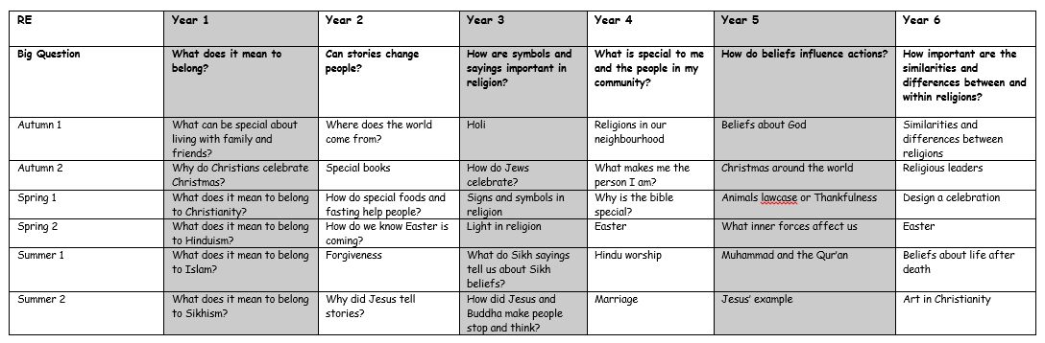
This is the curriculum overview for KS1 and KS2 RE:

- The teaching of RE lessons are based around ‘themes’ rather than focusing on a particular religion each term. The idea is for children to see how religions are all very similar and have some connecting views. This facilitates a larger focus on dialogue rather than just debate. As a result, there is a wider coverage of RE throughout the school.
- By organising the curriculum in this way, it has ensured that there is a development of RE as the children progress through the school.
- Children have the chance to experience trips to local places of worship to further enhance and engage children in a broad range of activities and to bring learning experiences beyond that of the classroom. Furthermore, religious leaders visit the school to support in lessons and deliver assemblies to celebrate a cross section of religious celebratory events throughout the year.

SECTION 3: Logistics and Organisation
Weekly Expectations
Nursery:
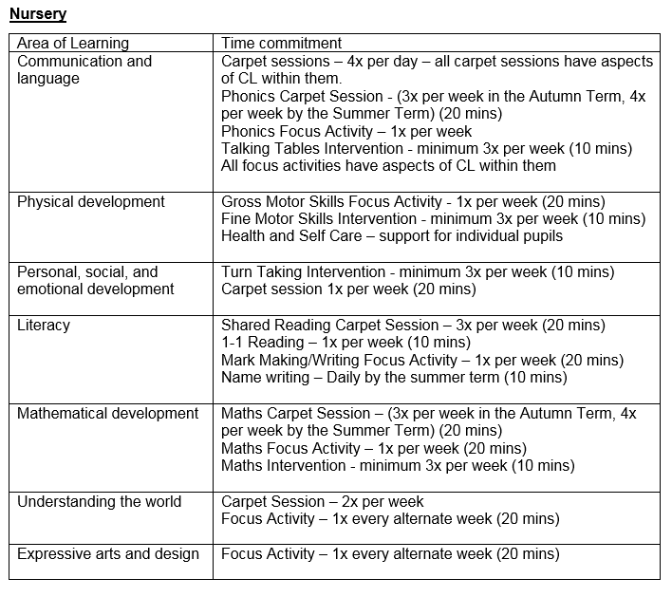
Reception:
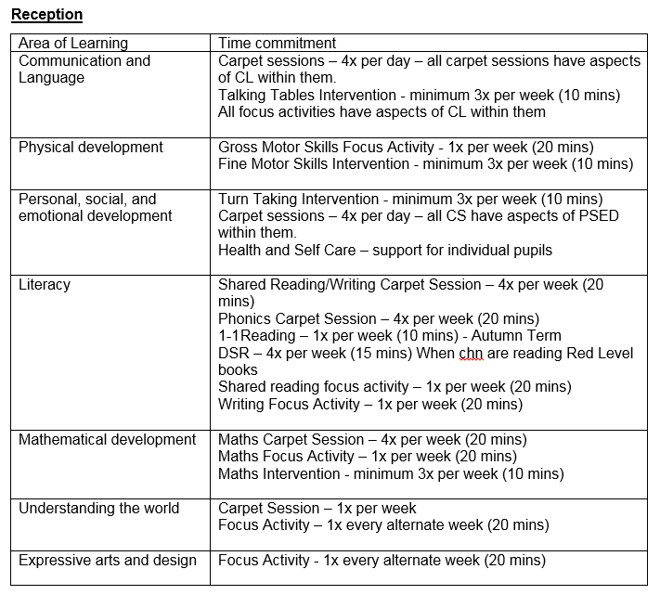

Key Stage 1:
Lesson: | Time Commitment:
Maths | 1 hour per day
Reading | 30 -45 minutes per day
Science | 2 hours per week
PSHE/ RE | 60 mins per 2 weeks (alternating)
Phonics | 30 mins, 5 days a week
SPAG/ Handwriting | 30mins, 5 times per week
Music/ Spanish | 45 minutes per two week (alternating)
PE | 2 hours per week
Early Work | 15 mins per day
Topic | 6 hours per week, at least 1 hour per day
Total: 24 hours per week.
The remaining time in school is broken into breaks, lunch and classroom routines or additional targeted learning.

Key Stage 2:
Lesson: | Time Commitment:
Maths | 1 hour per day
Reading | 45 minutes per day
Science | 2 hours per week
PSHE/ RE | 60 mins per 2 weeks (alternating)
SPAG/ Handwriting | 30mins, 5 times per week
Music/ Spanish | 45 minutes per two weeks (alternating)
PE | 2 hours per week
Early Work | 15 mins per day, 5 days a week
Topic | 7 hours per week, at least 1 hour per day
Total: 24 hours per week.
The remaining time in school is broken into breaks, lunch and classroom routines or additional targeted learning.

A Typical Day for a Child
Nursery:

08:45 -08:55 | Staff welcome children/families
08:55 – 09:10 | Self-registration.  Staff help the children to put their belongings away. They are introduced to the activities that have been set up inside.
09:10 – 09:30 | Phonics carpet session
09:30 -11:00 | Small group activities/independent play – indoors and outdoors
11:00 – 11:30 | Maths carpet session
11:30 – 12:00 | Lunch time
12:00 – 13:30 | Small group activities/independent play – indoors and outdoors
13:30 – 13:50 | Topic carpet session
13:50 – 15:00 | Small group activities/independent play – indoors and outdoors
15:00 – 15:15 | Story time

Reception:
08:45 -08:55 | Staff welcome children/families
08:55 – 09:05 | Registration.  Early morning work
09:05 – 09:30 | Phonics carpet session
09:30 -11:00 | Small group activities/independent play – indoors and outdoors
11:00 – 11:30 | Maths carpet session
11:30 – 12:30 | Lunch time
12:30 – 13:30 | Shared reading/writing
13:30 – 14:00 | Topic carpet session
14:00 – 14:50 | Small group activities/independent play – indoors and outdoors
14:50 – 15:15 | Story time

Key Stage 1:
8:45 – 9:00 | Early Morning Work: Focus on basic skills
9:00 – 10:00 | Maths Lesson
10:00 – 10:15 | Daily Exercise
10:15 – 11:00 | Phonics Daily Exercise
11:00 – 12:00 | Topic
12:00 – 12:45 | Lunch Time
12:45 to 1:00 | Assembly [some changes may occur]  Achievement awards or Singing, workshare, Current affairs….
1:00 – 2:30 | Science/ RE or PSHE/ Spanish or Music/ PE/ Topic
2:30 – 3:00 | Reading [DSR/DR
3:00 – 3:15 | Reading: Class Story/end of day activity

Key Stage 2:
8:45 – 9:00 | Early Morning Work: Focus on basic skills
9:00 – 10:15 | Maths Lesson
10:15 – 10:30 | Daily exercise
10:30 – 10:45 | Assembly [some changes may occur]  Achievement awards or Singing, workshare, Current affairs….
10:45 – 11:30 | Destination Reader
11:30 – 12:30 | Topic
12:30 – 1:30 | Lunch Time
1:30 – 2:00 | SPAG
2:00 – 3:15 | Science/ RE or PSHE/ Spanish or Music/ PE/ Topic/ Class Story

After School Clubs – Enrichment
We set ourselves a high expectation that we fully want to provide children with a range of additional extra-curricular activities. This is not only to support the academic work that is achieved within lesson but also a chance for children to experience other aspects of curriculum areas beyond the taught curriculum. In order to achieve this, at Oliver Goldsmith we provide a variety of clubs for our children to attend. As well as having an abundance of lunchtime clubs, such as chill out, sporting activities and games, children are also invited to a range of after school clubs.

We believe that all children should be given the chance to attend at least one after school enrichment club per academic year. The school offer a wide range of opportunities for children to access outside the school day including:
- Arts and Craft
- Cookery
- Sports – such as Basketball and Football
- Additional Spanish
- Drama
- Dance
- Computing
- Gardening
- Booster (Y6 additional tutoring club)

Children have the option of which clubs are on offer within their allocated half term and undertake a six week period of 60 minutes per day.
Parents are asked for a voluntary contribution to assist in covering the cost of materials and tuition. The school subsides the remaining cost of any club through pupil premium funding.

SECTION 4: EVIDENCING THE IMPACT OF OUR INTENTION
Measuring the Impact of the Curriculum
Formative Assessment – Assessment for Learning:
The key way that we decide of children are able to access the curriculum is the expectation that teachers plan effective lesson – teaching children well and engaging them to want to know more. Throughout all lessons, we expect adults to be monitoring children’s ability to access the curriculum, achieve explicit lesson objectives and plan for children’s progress when they are ready to move on.
Teachers use a range of strategies to gage how well children are progressing within lessons. This includes:
- Observations
- Questioning
- Whiteboard work
- Partner Talk and whole class discussion
- Monitoring children complete their independent work.
Challenge is crucial in our curriculum. It is our expectation that children are monitored throughout all aspects of the taught curriculum and action taken to ensure that children are accessing a lesson that is pitched for them. If the work is too hard, it is expected that additional support, differentiation or scaffolding is provided so children can achieve the lesson objective. If the work is too easy, additional challenge is swiftly put into place so children do not waste their time doing work that they can already do. This ensures that all children are able to make progress and move onto the next stage of their learning when they are ready to do so.
Curriculum Review – Medium Term Planning – Weekly Planning:
Every half term, teachers collectively work together to reflect on the opportunities that children have received, how well the curriculum has been implemented and what needs to adapted and planned for in the next half term in order for children to receive the best quality of education.
These review sessions are also designed to allow teachers to focus on the following areas:
- What were the strengths of the learning that occurred and how can we apply this for future practice?
- What do we need to develop in order to improve the learning experiences of all children?
- Did all children make enough progress within the curriculum and what needs to be planned next?
- Was the learning planned suitably pitched, differentiated, supported and challenged so all learners were able to access an education was right for them at this stage of their learning?
- Was the sequence of learning relevant, logical and provide children the best chance to make as much progress as possible?
Monitoring – Teaching and Learning Observations and Learning Walks
Senior Leaders undertake termly monitoring that focuses on teacher performance through the eyes of children’s experiences and learning. Children remain at the heart of observations, work book looks and planning scrutinies to ensure that all children are receiving the best chance to reach their potential. Feedback to teachers is recorded on a singular document to provide clear, effective and manageable targets to improve teacher performance and children’s outcomes.
Pupil Voice:
Frequently children are asked about their learning, what they are learning, why they are learning, what they enjoy about their topics and what they want to know more about. We believe in children articulating their learning as a skill and we ensure that frequent opportunities are provided in order to achieve a high level of oral communication about what children have learnt.
Expectations of Children’s Outcomes
Evidence of Progress – Children’s Books and Pupil Voice:
We believe that the best way to measure children’s progress is through talking to pupils and through looking at the recorded outcomes in children’s books. Children’s books across all aspects of the curriculum should provide evidence into the learning experiences of the child and be a basis for teachers to be able to make assessment judgements of children’s achievement. Children should also be able to articulate their learning, through recalling knowledge and facts that they have been taught. Therefore, book looks happen at least every half term by either senior or middle leaders – to monitor the provision for children, classes and year groups – to ensure that learning experiences are planned, delivered and recorded for monitor progress of children. Pupil voice should take place at every given opportunity, so children can practice recalling and articulating a response to what they have been taught.
Whilst there are no exact amounts of outcomes expected in each book, it would be anticipated that coverage of the curriculum should be evidenced enough to illustrate what the children have encompassed during their learning journey. Enough work must be evident to inform summative assessment data – and this is checked during moderation and book looks from middle and senior leaders. Children will also be asked and questioned in regards to their learning to correlate the outcomes in books match the learning that each child can remember. Children will be asked about current learning, as well as learning that may have taken place earlier – to ensure that children are making effective links and building on their prior knowledge.
Presentation:
All staff have high expectations for children’s presentation in recorded outcomes. Children are taught explicitly how to present their work neatly and teachers have high expectations that allow for children to take pride in their work and their outcomes. Aspects of presentation include:
- Best Handwriting
- Careful use of a ruler, including drawing margins
- Underlining dates and learning objectives
- Sticking in sheets neatly and carefully
- Using neat lines to correct any mistakes

Marking and Responding:
At our school, we value marking and the opportunities that it provides to give direct feedback of children’s success and next steps for learning. We do not believe in exhaustive marking but marking should be purposeful in moving children on in their learning. We very much value direct verbal feedback and asking children to reflect on their work – either independently or with an adult. We have a marking code that teachers are expected to use – with children being given opportunities to respond to marking to action the advice from the teacher. These responses are completed in Green Pen. Teachers are asked to be selective of the work that is expected to be marked in depth and the work which children respond to manage their own workload effectively. We believe that to make a difference to children’s learning, marking and responding to marking should be purposeful, useful to the child and illustrate how it is being used to move children forward – or celebrate their success at making progress.
Varied, Creative and Open Ended:
We believe that activities that children complete in lessons stem beyond just worksheets. Whilst we recognise that worksheets have a place in children’s learning, these must be purposeful to the skill or knowledge that the children are being asked to demonstrate. Alternative outcomes, through engaging learning opportunities are planned so children can present their learning in a variety of ways. Children should be given enough space to complete work of their level. In order to achieve this, allowing children to complete open ended task – without limitation to stunt children’s progress.
Exercise Books:
Exercise books are a record of the children’s learning and therefore a precious document that contains a lot of effort, evidence and hard work. Therefore, exercise books are well cared for and kept for the entire academic in order to evidence the curriculum that has been taught, and how well children have achieved and progressed within it.

Summative Assessment Data Procedures
Attainment and progress across every year group is measured at three points of the year:
- Autumn 2:
This assessment period allows senior leaders to get a snap shot of the class achievement at the start of the year. It allows us to set targets, adjust provision from the previous academic year and also allow provision maps to be reviewed, edited and action taken to inform future provision.
- Spring 2:
This data snapshot allows us to evaluate the teaching and learning at this mid-term point in the year. It allows leaders to triangulate data from lesson observations, book looks and planning scrutinies to ensure a full picture of the education that children are receiving is of the highest quality.
- Summer 2:
This allows leaders to review the attainment and progress across the academic year. This data drop allows us a quantitative measure to align with teacher judgements and facilitate effective handover between academic years in order to ensure transition between year groups and key stages are seamless.
Teacher Assessment Data Expectation – by Year Group and Term:
- Attainment Benchmarks by Term:
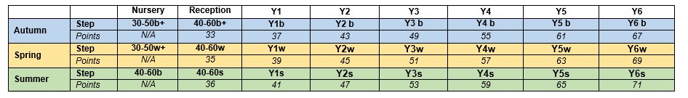
- Progress Benchmarks by Term:
Term 1 |  | Term 2 |  | Term 3
Progress from Summer-Autumn |  | Progress from Summer - Spring |  | Progress from Summer - Summer
APP across 1 term |  | APP across 2 term |  | APP across 3 terms
Poor progress | <1.5 | Poor progress | <3.5 | Poor progress | <5.5
Slow progress | 1.5—1.9 | Slow progress | 3.5—3.9 | Slow progress | 5.5—5.9
Expected progress | 2.0—2.5 | Expected progress | 4.0—4.5 | Expected progress | 6.0—6.5
Rapid progress | 2.6+ | Rapid progress | 4.6+ | Rapid progress | 6.6+

Pupil Progress Meetings:
Pupil Progress Meetings are held each term with individual classes and sometimes whole year groups. The purpose of these meetings are:
- To ensure the progress of all children is in line with expected progress or better.
- To discuss data trends and how this can be targeted in class in order to ensure that all children can make progress
- To adjust provision maps, meaning that interventions are having impact and the right children are being targeted to make accelerate progress in order to close the gap between groups of children whom may be disadvantaged or present with barriers to learning.
Leaders are fully aware of the advantages of data analysis, as well as the limitations of data analysis. Ultimately, the data is used to inform conversations during pupil progress meetings – and in turn this may adjust provision for children. We believe in considering data, whilst utilising a triangulated approach to data, lesson observations and children’s outcomes in books provide valuable accountability and a more accurate picture to help leaders and teachers adjust provision for children, as necessary, to so all children can make accelerated progress to achieve their potential.

NB: Due to the restrictions of COVID some areas of our intent will be re-established and assessed. This includes the provision of music. External providers shall be re-established to promote our music curriculum as quickly and thoroughly as possible.

