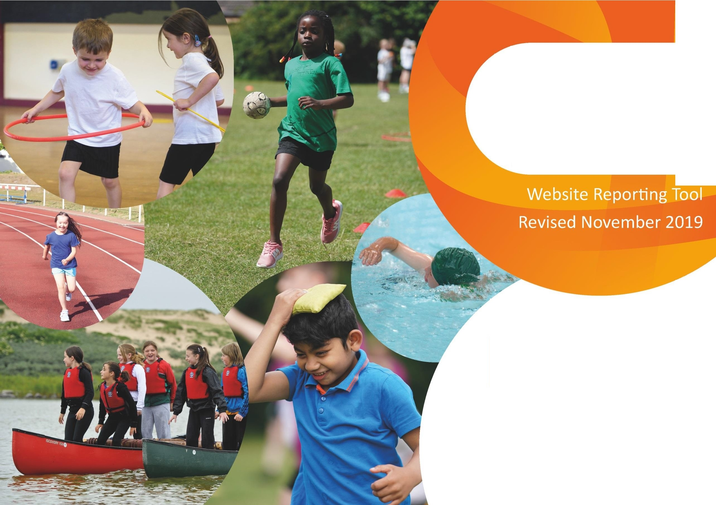
Evidencing the Impact of the Primary PE and Sport Premium

Revised July 2021

Commissioned by
•

Department for Education

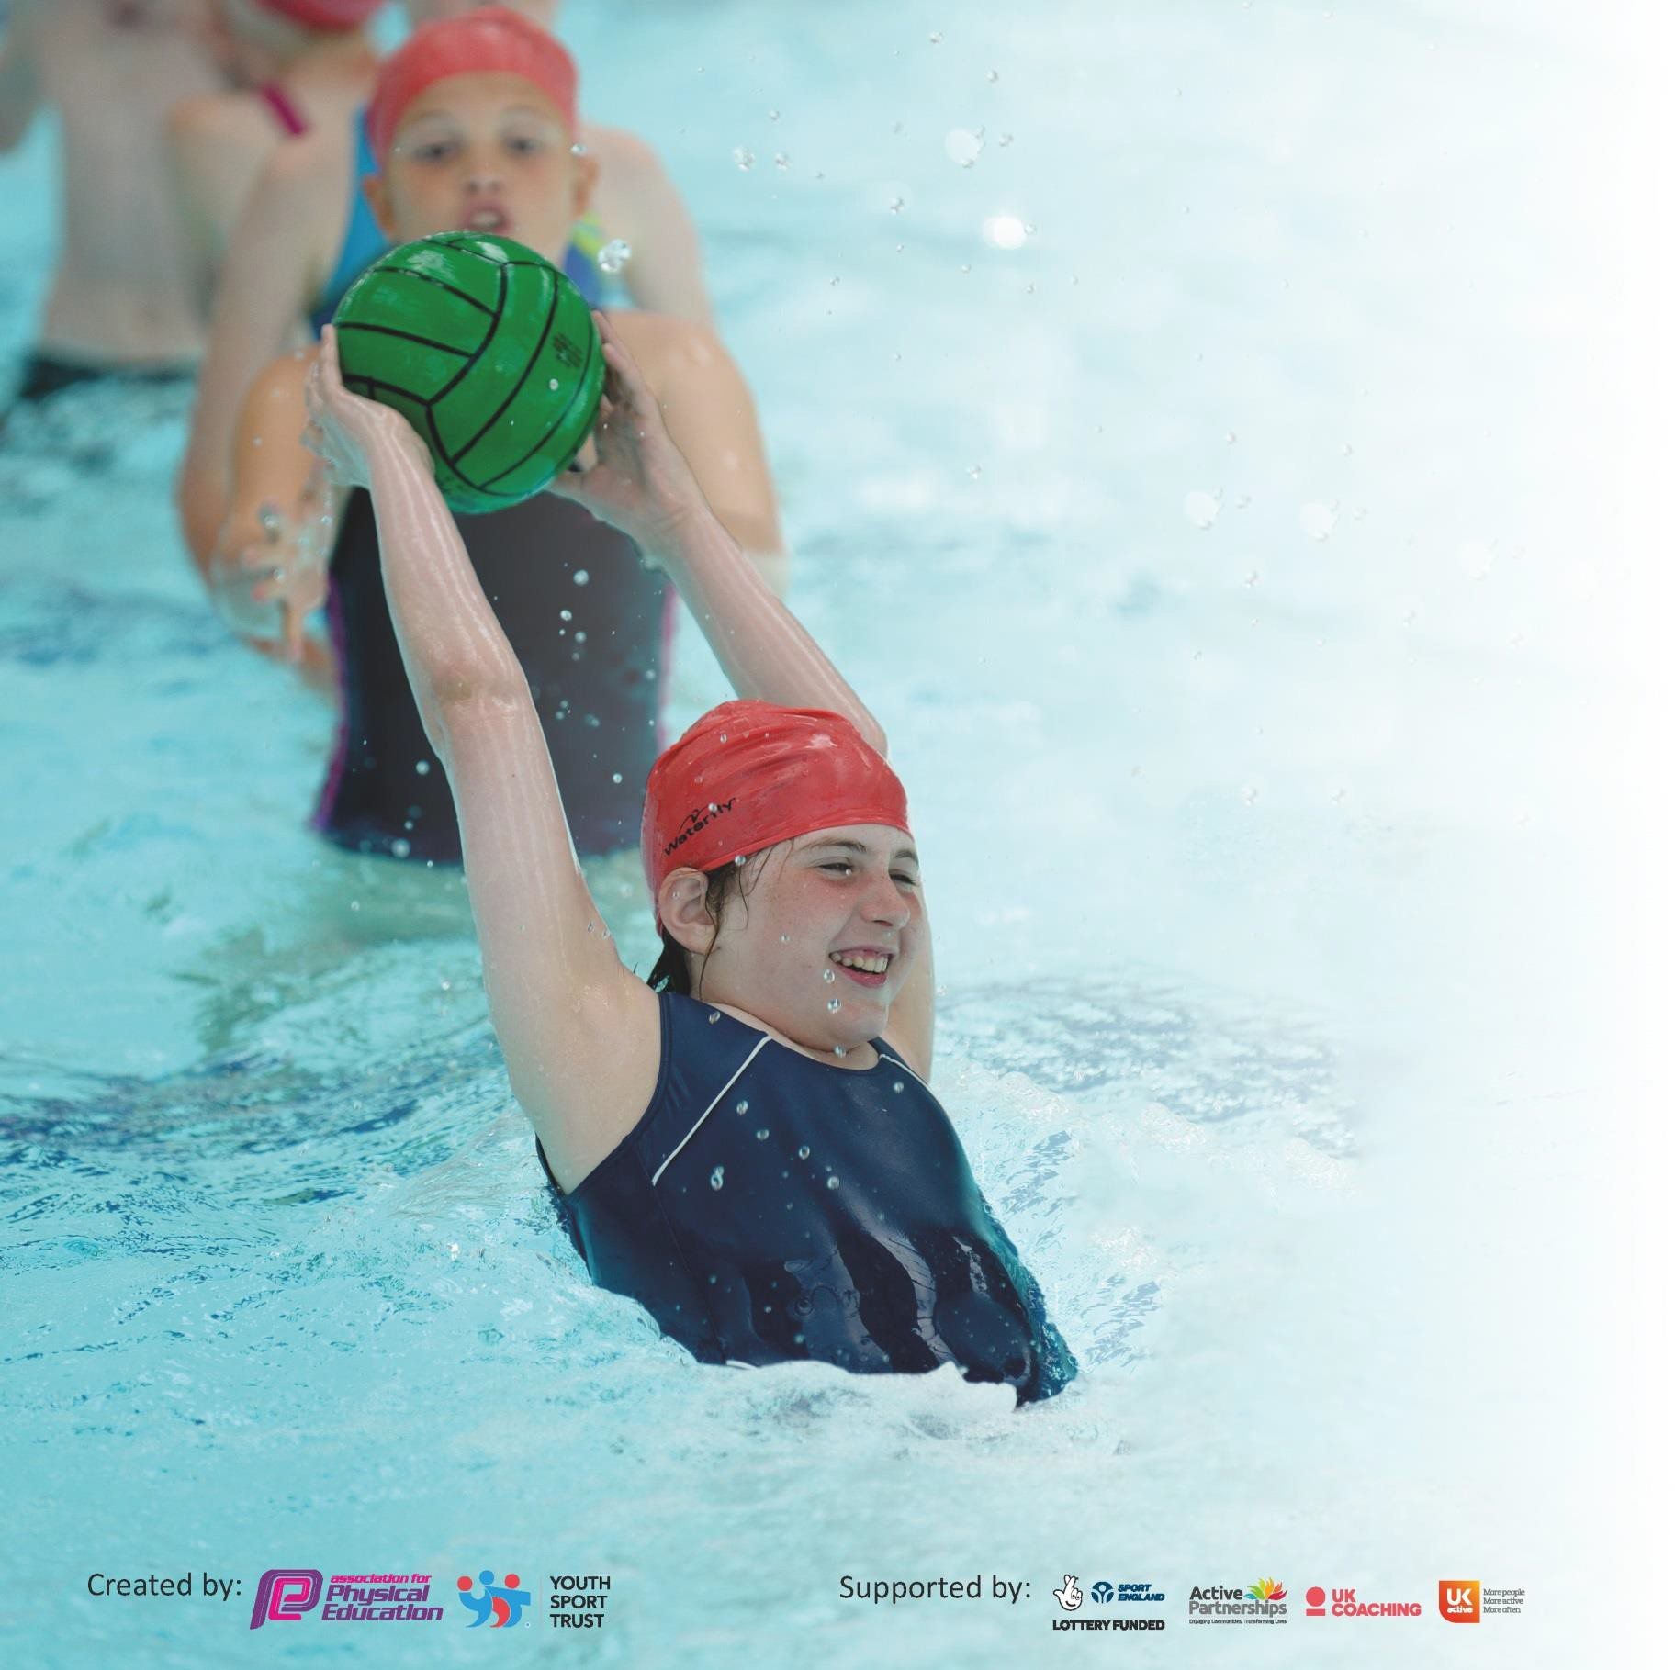
It is important that your grant is used effectively and based on school need. The Education Inspection Framework (Ofsted 2019 p64) makes clear there will be a focus on ‘whether leaders and those responsible for governors all understand their respective roles and perform these in a way that enhances the effectiveness of the school’.

Under the Quality of Education criteria (p41) inspectors consider the extent to which schools can articulate their curriculum (INTENT), construct their curriculum (IMPLEMENTATION) and demonstrate the outcomes which result (IMPACT).

To assist schools with common transferable language this template has been developed to utilise the same three headings which should make your plans easily transferable between working documents.

Schools must use the funding to make additional and sustainable improvements to the quality of Physical Education, School Sport and Physical Activity (PESSPA) they offer. This means that you should
use the Primary PE and Sport Premium to:

- Develop or add to the PESSPA activities that your school already offer
- Build capacity and capability within the school to ensure that improvements made nowwill benefit pupils joining the school in future years

Please visit gov.uk for the revised DfE guidance including the 5 key indicators across which schools should demonstrate an improvement. This document will help you to review your provision and to report your spend. DfE encourages schools to use this template as an effective way of meeting the reporting requirements of the Primary PE and Sport Premium.

We recommend you start by reflecting on the impact of current provision and reviewing the previous spend.

Schools are required to publish details of how they spend this funding as well as on the impact it has on pupils’ PE and sport participation and attainment by the end of the summer term or by 31st July 2021 at the latest.

We recommend regularly updating the table and publishing it on your website throughout the year. This evidences your ongoing self-evaluation of how you are using the funding to secure maximum, sustainable impact. Final copy must be posted on your website by the end of the academic year and no later than the 31st July 2021. To see an example of how to complete the table please click HERE.

Support for review and reflection - considering the 5 key indicators from DfE, what development needs are a priority for your setting and your pupils now and why? Use the space below to reflect on previous spend and key achievements and areas for development.

Key achievements to date until July 2021: | Areas for further improvement and baseline evidence of need:
- Children across the school engaged in regular physical activity with outstanding teaching with their teacher or trained TA. Staff will get consistent support from PESSN  - Improved confidence among teachers and support staff in delivering PE lessons as a result of quality CPD provided by PESSN  - A variety of competitive sporting events offered which led to an increase in confidence and willingness to participate among the pupils  - A successful sports week held at Burgess park for KS1 and 2 and in school for EYFS. All children participated  - Several enrichment activities offered after school – gymnastics, multi skills, netball, football and tennis  - Continued encouragement and promotion of PE and Healthy lifestyle choices throughout lockdown.  - The school remained open all year – including offering Healthy Food parcels to families and welcoming them into school to take part in activities with a charity run organisation. | - Ensure that all children be given the opportunity to participate in competitive sport  - To ensure that all groups are making expected or better progress in lessons e.g. G & T and SEND  - Ensure effective CPD for all teachers and target new members of staff  - Have a focus on health and well-being across the school to further profile of PESSPA  - Plan for a range of sports and activities to be offered to all pupils

Meeting national curriculum requirements for swimming and water safety. (On hold for now due to COVID restrictions)
What percentage of your current Year 6 cohort swim competently, confidently and proficiently over a distance of at least 25 metres?  N.B. Even though your pupils may swim in another year please report on their attainment on leaving primary school at the end of the summer term 2020. | 81%
What percentage of your current Year 6 cohort use a range of strokes effectively [for example, front crawl, backstroke and breaststroke]? | 64%
What percentage of your current Year 6 cohort perform safe self-rescue in different water-based situations? | 8%
Schools can choose to use the Primary PE and Sport Premium to provide additional provision for swimming but this must be for activity over and above the national curriculum requirements. Have you used it in this way? | No

Action Plan and Budget Tracking
Capture your intended annual spend against the 5 key indicators. Clarify the success criteria and
evidence of impact that you intend to measure to evaluate for pupils today and for the future.

Academic Year:  2020/21 | Total fund allocated: £19306 | Date Updated: July 2021
Key indicator 1: The engagement of all pupils in regular physical activity – Chief Medical Officer guidelines recommend that primary school pupils undertake at least 30 minutes of physical activity a day in school |  |  |  | Percentage of total allocation:
 |  |  |  | 36%
Intent | Implementation |  | Impact
Your school focus should be clear what you want the pupils to know and be able to do and about what they need to learn and to consolidate through  practice: | Make sure your actions to achieve are linked to your intentions: | Funding allocated: | Evidence of impact: what do pupils now know and what can they now do? What has changed? | Sustainability and suggested next steps:
Give pupils extra sporting activities outside of the normal curriculum requirement | A varied range of Enrichment clubs offered before and after school  Sporting activities in different year groups including: football, multi sports, basketball, and netball  A weekly session of physical activity with a sports coach for all children | £7,000 | Children will have the opportunity to experience different sports such as netball, football, tennis, badminton and yoga from experienced coaches. This will ensure all children have an opportunity to experience team games and individual talent sports. This will also identify those who have a talent for a particular sport or those who enjoy the participation and get encouraged in a team environment. | By offering a range of physical activities before and after school (as well as during school holidays for key worker children) we hope that many children will engage in activities beyond those provided during PE lessons.
Promote Health & Wellbeing | To run at least one Health & Wellbeing programme with two year groups (parent/child workshop) |  | The PSHE and PE subject leaders will run whole school assemblies, workshops and PE Outdoor activities promoting wellbeing and special awareness for those children who live in overcrowded situations with no access to a garden or outdoor space. This will introduce and explore positive ideas around healthy eating choices and physical activity. Feedback from the kitchen staff and mealtime supervisors will show that children demonstrate knowledge of a balanced diet by making healthy choices lunch time.  The uptake of after school clubs will improve | To ensure sustainability, the Healthy body, Healthy mind and creating opportunities linked to other subjects in the curriculum, for example PSHE and mental health  Children and their families will embrace and practice strategies acquired from the sessions.
Key indicator 2: The profile of PESSPA being raised across the school as a tool for whole school improvement |  |  |  | Percentage of total allocation:
 |  |  |  | 44%
Intent | Implementation actions to achieve are linked to your intentions: |  | Impact Evidence of impact: | Sustainability and suggested next steps

The profile of PE and sport being raised across the school as a tool for whole school improvement with the support of the Bacon’s PE & Sports Network. | Athletics and teamwork activities to be a focus for majority of PE lessons in summer term leading to a Sports day held at the end of the academic year.  Rewards for achievements at the sports day  Enter competitive events with local schools organised by PESSN  Train children to become play leaders through the PESSN leadership programme  Through PESSN identify and develop pupils who are gifted and talented in sports and support them to join local clubs | £4,400 | There will be a raised interest in sporting activities across the school. PESSPA (Physical Education, School Sport and Physical Activity) will be a major part of the school ethos  Children will take pride in the school’s sporting achievements;  this will be evidenced in pupil voice, sports day challenges and achievements by sponsorships of activities. This will be rewarded by medals.  The percentage of parents attending sporting events organised by the school to support children will increase.  Parents will enrol children in other externally organised local sporting activities and interest for more clubs in schools.  Evidence of a positive attitude towards healthy eating and exercise.  Positive mind set evident in pupil voice  Pupils who are gifted and talented in sports will be given appropriate support and put forward for inter school sporting events | Data will show a growing number of pupils are actively engaged in sporting activities either in or out of school.  Information shared with parents about local, out of school activities available in flyers, the school website and newsletter.  Food boxes provided during school holidays and healthy eating choices shared through menus and ingredients sent home to encourage cooking and eating together. As well as links to online workouts, yoga, etc.
Leadership opportunities for pupils.  Improved behaviour and independent working skills of pupils through group work.  Building pupil self- confidence mind set and resilience. | Provide circus skills for the whole school and to promote teamwork, as well as individuality in skills identified and encouraged. For children to show leadership and independence.  Reporting of children’s sporting achievements on school website and newsletter. | £4,000 | Children able to evidence their abilities through whole school assemblies and performances.  To show confidence in delivering new skills amongst their peers. | Healthy Living Week, Embed Healthy competition.  Staff trained to deliver Sports Leaders training so that 10 children from each upper KS2 class can be trained

Key indicator 3: Increased confidence, knowledge and skills of all staff in teaching PE and sport |  |  |  | Percentage of total allocation:
 |  |  |  | 11%
Intent | Implementation |  | Impact | Sustainability and suggested next steps:
CPD programme run by PESSN and the PE subject leader | Subject leader to identify curriculum CPD needs and work with PESSN to deliver at least one twilight INSET  Block four weeks of team teaching with PESSN professionals for up to three teachers (NQT and  2 teachers new to the school) | £500 | Evidence from monitoring of teaching and learning will show that pupils make good progress in PE lessons due to an increase in the number of teaching staff who have received PE training and support in specific areas | Teachers who have received the training to share good practice with each other through peer observations  Next step is embedded assessment of PE across the school.
School Games Mark | Subject leader to identify the areas related to PESSPA (Physical Education, School Sport and Physical Activity) that need to improve so that the school is in a position to apply for the School Games Mark bronze award  Actions taken and evidence gathered for the Bronze award by summer 1  Application done by the end of summer 1 |  | Evidence collated and shared with staff will showcase the impact of PE, sport and health across the school  Identify any new resources that could benefit pupils and develop PE lessons. | Continue building on the positive areas identified and identify ways of achieving the silver award next year
Raise the knowledge of the new subject leader to monitor, lead subject and PESSPA across school | Subject Leader to undertake PESSN courses throughout the year in order to up-skill my own knowledge and understanding so I can confidently disseminate to all staff.  Subject leader to team teach/observe identified members of staff |  | As a result of good leadership in the subject and confident and knowledgeable staff, all pupils will make good or better progress, building on prior achievement  Increased confidence, self-esteem and a real desire to learn. The enjoyment of PE increased participation in wider activities (30% increase in club attendance, with 91% of all pupils attending one or more clubs) Development of co-operation/working in groups/desire to learn  There are fewer non-participants in competitive sport | The subject leader will be allocated ongoing staff meeting time once per term; together with slots in professional development days to ensure all staff are kept up to date and that new staff are brought up to speed
Key indicator 4: Broader experience of a range of sports and activities offered to all pupils |  |  |  | Percentage of total allocation:
 |  |  |  | 18%
Intent | Implementation Actions to achieve: |  | Impact Evidence of impact: | Sustainability and suggested next steps:
To identify and create pathways for talented students in PE | To organise gifted and talented identification sessions facilitated by PESSN  Subject leader to support teachers in adapting planning to cater for the identified talented children  After School Enrichment clubs tailored to meet the needs of the pupils identified as G&T | £3406 | Children identified as talented in gymnastics will develop the relevant skills to compete in events organised by PESSN  A variety of enrichments clubs offered to all pupils after school 4 days per week. | The after-school club will lead to pupils taking their interest of sport into secondary school  Next steps: Work with Southwark Gymnastics to get talented gymnasts in competitive sport

To enhance ‘Support  /SEND’ opportunities in PE and maintain attendance at festivals/events |  | (Gymnastics club run by a coach for children identified as having an aptitude for the discipline)  Families supported to enlist identified children in local clubs  Adapt planning to ensure ‘Support /SEND’  children make progress in lessons  Attend SEND festivals/events.  Circus skills to be done during PPA times weekly to allow children to experience a broader range of activities  Support staff to be trained in Circus Skills to introduce activities more generally in the playground  Circus skills equipment to be ordered |  |  |  | The after school enrichment club for gifted and talented children will have 100% uptake and 50% will be supported to enrol in local clubs that offer completive gymnastics  Teacher feedback and assessment will show that support  /SEND children make progress in lessons and across units of PE work |  | Subject leader and SLT will monitor performance of identified groups throughout the year  Subject leader will ensure that all planning is adapted to benefit t all groups of pupils
 | Key indicator 5: Increased participation in competitive sport |  |  |  |  |  |  |  | Percentage of total allocation:
 |  |  |  |  |  |  |  |  | TBC
 | Intent |  | Implementation |  |  |  | Impact
 | To increase the attendance at whole day/half day competitions and events |  | Enter whole class events, spread the events across KS1 & 2 ensuring that each year group attends at least one event in the year |  |  |  | A wide range of competitive and non-competitive activities opportunities for more children across the school  Over 90% of children will have taken part in a sporting event or competition this academic year |  | More children will express interest in after school and lunchtime sports clubs The school will set up lunchtime and after school sports clubs due to the  high demand
 | To promote girls football & Netball in the school |  | Girls will be given opportunities to play girls only football & Netball during timetabled lunch time activities sessions. |  |  |  | 30 Year 5 girls will gain the skills and confidence to play football with the intention of joining the school football team  Meal time supervisors/LSAs will report that more girls are participating in football during playtime  Pupil voice and data from the young sports leaders will evidence that more girls are participating in football in the  playground |  | The school will set up a girls’ football team which will participate in the local league  Girls will develop the confidence and interest to join local out of school football teams
 | Promote a positive attitude to  Healthy competition  Build confidence and skills in football and netball |  | To register and participate in PESSN Primary Football League  Hold weekly training sessions and enter inter school competitions as well as play in the league  (TBC) |  |  |  | Children will develop football and netball skills as well as cultivate a positive attitude towards healthy competition. Children will develop teamwork skills  Pupil voice and results from competitions will show that  children’s skills are improving |  | Once a term football and netball clubs achievements will be celebrated in whole school assemblies with team members being given the opportunity to inspire others

Signed off by
Head Teacher: | Lesley Murdoch
Date: | 20th July 2021
Subject Leader: | Sophia Campbell-Whitfield
Date: | 20th July 2021
Governor: | Denise Williams Dean
Date: | 20th July 2021

