Year 6 Homework Autumn 2
Each week, choose something from the table below to do as homework. You should spend at least thirty minutes on this each week.
Please present your homework with a clear title (underlined).
- Use pen, pencil and coloured pencils in your book. If you want to create a display piece then please do so.
- You are expected to use neat handwriting and take care with spelling and punctuation.
- The amount of work produced should reflect the work that you complete in class. You are in Year 6, think carefully about what is expected of you.
Write a fact-file about one of the four cities (Paris, Munich, Budapest or Bucharest) from our class book Secrets of the Night Train.  MUST - include the geographical position, place of attraction or interesting moments, language and currency or population  SHOULD – Include figurative language to create an image of the scene.  CHALLENGE – should imply but not reveal the actual location. | Design a travel poster to advertise a country in Europe.  MUST – Include images, pictures and slogans e.g. “Visit Spain, the land of beautiful beaches!”  SHOULD –Include persuasive features to persuade people to attend.  CHALLENGE – Use your knowledge of the country’s terrain or topographic images to inform your writing. | Try or research an example of European food from a European country and write a review.  MUST – Use the five tenses to give a detailed description of its appearance or presentation.  SHOULD – Give reasons why (or not) you would recommend that dish to someone else.  CHALLENGE – Include a list of ingredients and its health benefits.
Research and write a traditional tale from a European country. The tale could be presented as a comic strip or usual story structure  MUST – have a beginning, middle and an end and include a clear plot with the good description of the main characters.  SHOULD – include dialogue which is clearly punctuated.  CHALLENGE – Include a link to other traditional tales that you may have read. | 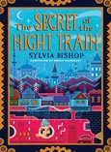  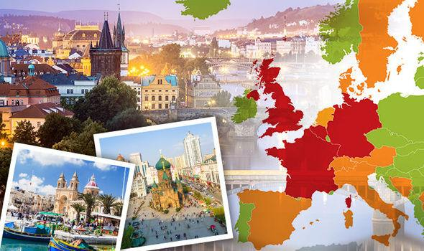  Europe | Make a model of a European monument – Eiffel Tower, Leaning Tower of Pisa, Colosseum, Brandenburg Gate…  MUST – Use materials that fit the purpose.  SHOULD – Include as much detail as possible.  CHALLENGE – Write a brief history about your choice of monument  nt.
Imagine you are visiting a location (city) in Europe; write a postcard/letter home telling your reader all about your trip.  MUST – Include effective vocabulary to convey emotion.  SHOULD – Use a range of sentence starters (fronted adverbials, -ing clauses etc).  CHALLENGE – Included geographical details such as landmarks, weather, language and culture of the chosen city. | Europe has one of the highest numbers of artist in the world, including Picasso, Van Gogh, Monet, Da Vinci, and Michelangelo. Create a piece of artwork based on an artist of your choice.  MUST – Use at least two forms of media (paint, pencil, chalk…)  SHOULD – Use the background to create a setting, based on the artist themselves.  CHALLENGE – Use quotes from the artists to annotate your creation. | Write a “Capital Cities of Europe” quiz. Research the countries of Europe and their capital cities then write questions e.g. In which capital city would you find The Kremlin?  MUST –Include multiple choice questions. E.g. What is the population of Paris? a) ...b)...or c)…  SHOULD – Include key facts about each city.  CHALLENGE –Include a variety of question styles such as ‘odd one out’, ‘What’s the same? What’s different?’ and so on.

