Flu Immunisation Consent Form 2022
Would you like your child to have the nasal flu immunisation at school?
Please scan the QR code below using your smartphone camera to direct you to the consent form website
Please do not fill out another form if you have already
Southwark Schools
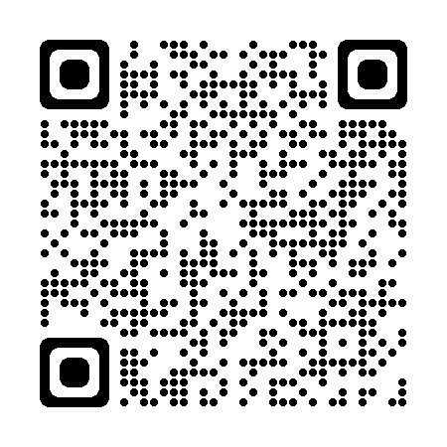
This form should take no longer than 2 minutes to complete
If you have any queries, please contact the Southwark and Lambeth Immunisation Team 0208 614 5496 / 5495
Hrch.ImmunisationTeamMailboxSouthwark@nhs.net
Hrch.ImmunisationTeamMailboxLambeth@nhs.net
Southwark and Lambeth School Age Immunisation Team

