Friday 16th December 2022
Dear Parents and Carers,

I would like to wish you a very happy holiday and I hope you have lots of festive fun.
It was wonderful to see so many of you at the Nativity and Christmas singing performances. It was great to see the children use their voices so well. I was particularly impressed with the bravery of our younger children speaking out so clearly on the stage.
Lots of prizes were handed out yesterday: The Football design competition and the PTA decorated Christmas tree competition. It was fantastic to see so many talented efforts. Well done to all who took part.
The Winter fair was great fun: thank you to the PTA for organising this event and for all who came to support too. £390.50 was raised!!
I loved seeing so many of you with your prizes and treats, I am sure SANTA will be remembering all those lovely requests from the children. I am looking forward to seeing you all in the New year when we return to school as normal on Wednesday the 4th of January 2023.

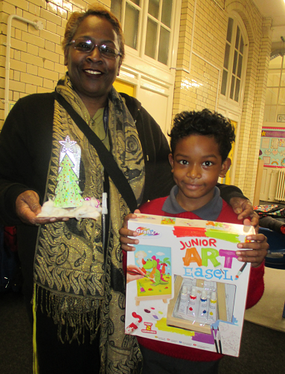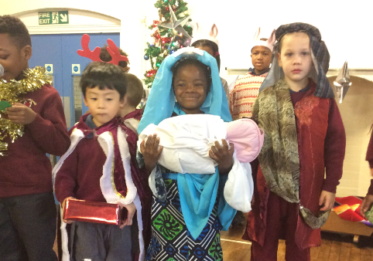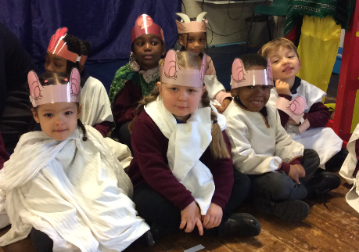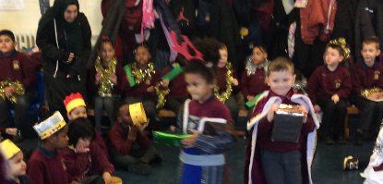
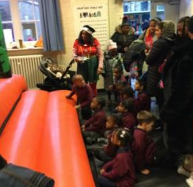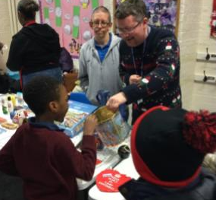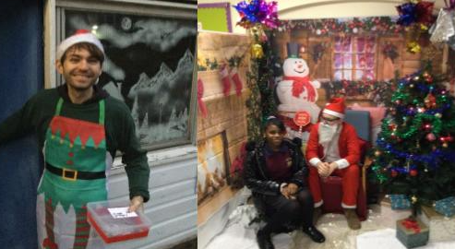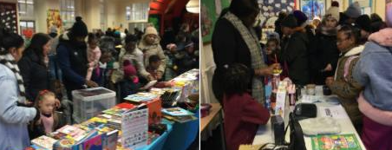

With best wishes
Have a Happy New Year!!!
From Ms Murdoch and the team at Oliver Goldsmith Primary School.

