Autumn 1- Kenya
- Pick one task each week and spend around 30 minutes completing the task
- BE CREATIVE and use what you have learnt in class as well as what you have researched/learnt at home
- Homework is given out on Friday. Homework should be handed in by the following Tuesday.

Where is Kenya?  Draw a map of the continent of Africa showing where Kenya is located? Can you also find the countries and sea that border Kenya?  Steps to success:  - Have you included a key in your map?  - Have you located some of Kenya’s most popular landmarks on the map?  Challenge: Write a short description of Kenya’s location in relation to the United Kingdom. Think about the geographical vocabulary needed. | My Journey around Kenya  Where would you like to visit in Kenya? Which places would you go to? What would you do there?  Plan an exciting journey around Kenya. You can visit as many places as you like!  (Ask your teacher for a journey template and map of Kenya to record your journey.)  Steps to success:  - Use a coloured pencil to trace your route on the map of Kenya  - Write the names of the places you visit clearly  - Explain why you would like to visit this place | Safari Adventure  Write an adventure story based in the jungles of Kenya. Who is your main character? Are there supporting characters? What heroic feat will your main character accomplish?  Steps to success:  - Take time to plan your story  - Include a beginning, middle and end  - Use expanded noun phrases to describe  - Include dialogue to make it interesting  Challenge: Include an image or two showing scenes from your adventure. (Ask your teacher for a story map/story mountain to help plan your journey)
Safari in a Shoebox  Show the rich wildlife and habitats of Kenya in your own safari diorama.  You will need: a shoebox or similar-sized box, construction paper/cardstock/ crepe paper, crayons/colouring pencils/paint/ scissors, glue.  (Ask an adult to supervise when using a scissors.)  Steps to success:  - Use orange, red or peach colour for the background of the box  - Remember to also focus on the landscape by including mountain, trees, grasslands, rivers etc | 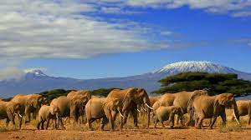  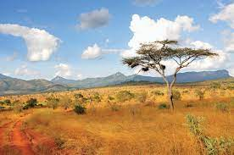  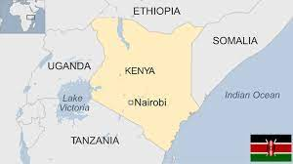  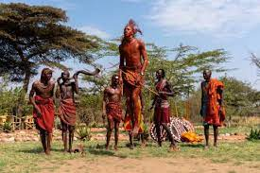  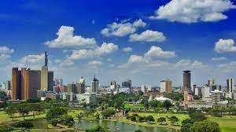  Kenya | Create a model of a Kenyan mask  African masks are traditionally made from materials like: wood, bronze, brass, copper, ivory, terra cotta, raffia or textiles. Think carefully about the material which might be available for your own mask, maybe cardboard, papier-mache, or textiles.  (Ask your teacher for some patterns to start you off.)  Steps to success:  - Have you used bold colours, as well as a range of shapes and patterns?  - Have you used interlacing crosses and geometric forms which are often seen on African masks  Challenge: What does your mask represent in the Kenyan culture? Give some information about this mask.
The Big 5 in Kenya  The big 5 animals in Kenya are: elephant, lion, leopard, rhinoceros and buffalo. Write an acrostic poem about one of these animals. In an acrostic poem, the first letter of each line spells a word. The word is the subject of the poem.  Steps to success:  - Write your animal down vertically  - Brainstorm words or phrases that describe your animal.  - Place your brainstormed words or phrases on the lines that begin with the same letters.  - Fill in the rest of the lines to create a poem.  Challenge: Can you present your poem to the class? Remember to practice reading it out loud and with expression a few times. | Food! Glorious Food!  What is a typical Kenyan meal? What do Kenyan’s have for breakfast, lunch and dinner?  What is your favourite Kenyan food? Mandazi? Ugali? or Githeri?  Create a Kenyan menu that’s delicious and nutritious.  Challenge:  Can you have a go at preparing a Kenyan meal and take some pictures to show.  (Adult support needed) | The Ultimate Quiz  Create a quiz about Kenya. This could be based on facts you have learned in class or on your own home learning.  (Consider waiting until you have gathered enough facts about Kenya before completing this task.)  Tips:  - Assign marks to your quiz.  - Have a range of types of questions, including some multiple choice  Once completed, challenge your friends in class to complete your quiz.
REMEMBER:
- Only use pencils in your homework books. No felt-tips or pens.
- Don’t forget to read every day.
- Please present your work as we expect in school - neat hand-writing and taking care with spellings and punctuation.

