Year 6 Homework Autumn 2
Each week, choose something from the table below to do as homework. You should spend a few days on each activity. Do not rush.
Please present your homework with a clear date and title (underlined).
- Use pen, pencil and coloured pencils in your book.
- You are expected to use neat handwriting and take care with spelling and punctuation.
- The amount of work produced should reflect the work that you complete in class. You are in Year 6, think carefully about what is expected of you.
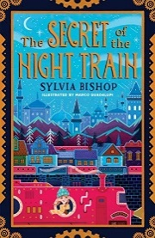  Write a fact-file about one of the four cities (Paris, Munich, Budapest or Bucharest) from our class book Secret of the Night Train.  MUST - include the population, language spoken and famous landmarks in that city. | 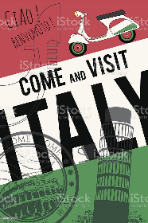  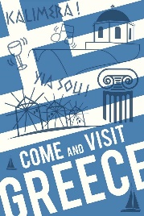  Design a travel poster to advertise a country in Europe.  MUST – Include images, pictures and slogans e.g. “Visit Spain, the land of beautiful beaches!” | Try some European foods and write a recipe of how to make the dish you tasted.  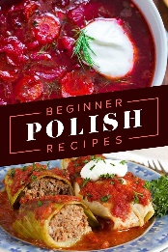  MUST – Use time connectives: first, next, then, after.
Research and write a traditional tale from a European country. The tale could be presented as a comic strip or usual story structure  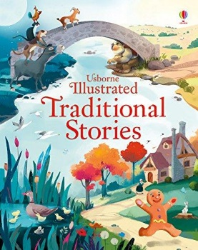  MUST – have a beginning, middle and an end. | 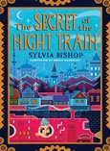  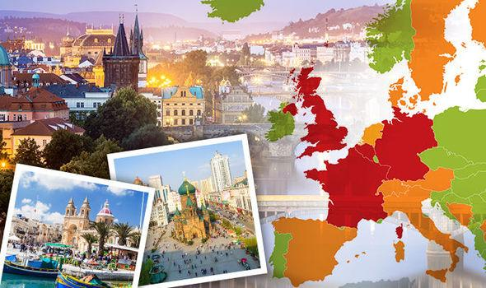  Europe | Make a model or drawing of a European monument – Eiffel Tower, Leaning Tower of Pisa, Colosseum, Brandenburg Gate…  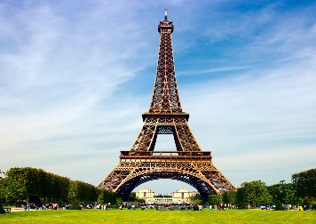  MUST – Use materials that fit the purpose.  SHOULD – Include as much detail as possible.
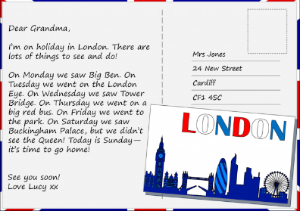  Imagine you are visiting a location (city) in Europe; write a postcard/letter home telling your reader all about your trip.  MUST – Include past tense to talk about your trip. | 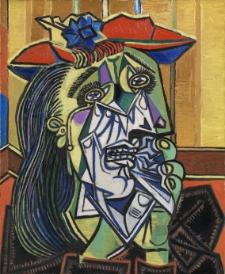  Europe has one of the highest numbers of artist in the world, including Picasso, Van Gogh, Monet, Da Vinci, and Michelangelo. Create a piece of artwork based on an artist of your choice. | Choose one European country and create a map of that country.  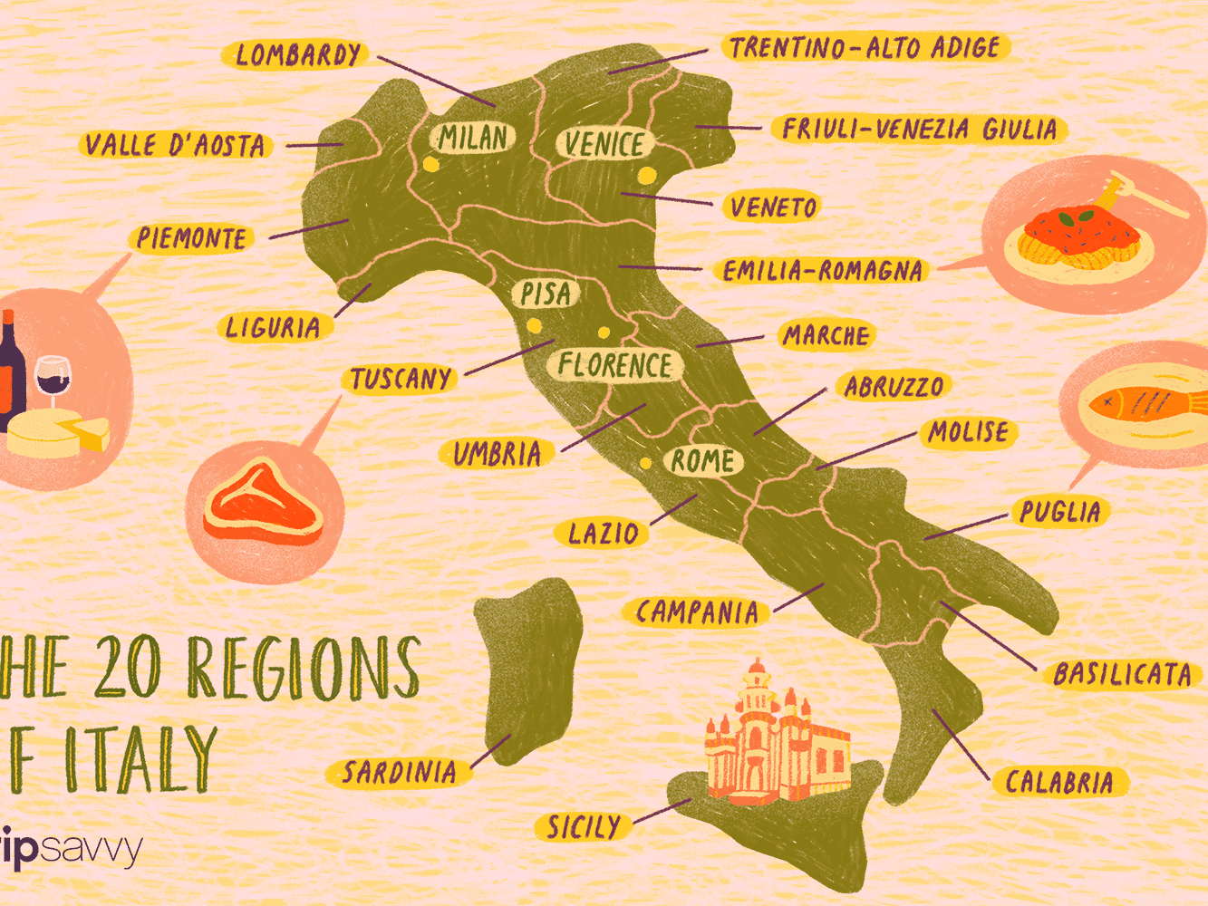  MUST – Label the capital cities and other major cities in that country.  SHOULD –Include the surrounding seas or countries.

