Year 5 Homework Autumn 2
Remembering Heroes!
Each week, choose something from the card to do as homework. You should spend at least thirty minutes on this each week.
Create a diary entry about being a soldier in WW1.  MUST – Be written in first person.  SHOULD – Include an interesting event in your daily life.  CHALLENGE – use art and writing to represent a key event of the War. | Research a weapon used in WW1  MUST – draw and describe a weapon used in WWI.  SHOULD –Explain how the weapon was used in WWI.  CHALLENGE – Write a short paragraph explaining the forces that apply to the weapon, and its impact on warfare. | Create a propaganda poster based on WW1.  Google Search: WW1 propaganda posters UK)  MUST – use images based on WW1 propaganda  SHOULD – include a powerful slogan  CHALLENGE – write a short explanation
Write a letter to your dad who has been sent away to fight in the trenches.  MUST – be written in first person.  SHOULD – use a range of sentence starters so it is interesting.  CHALLENGE – consider how he would feel reading it. Would you want him to think you are happy or worried? | 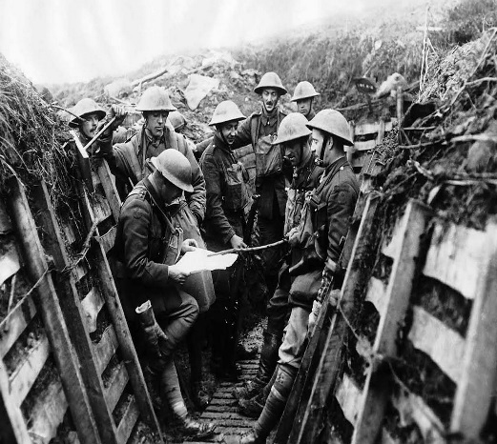 | You are being sent to the trenches to fight. What would you take with you?  MUST – use because to explain your choices.  SHOULD – use a range of causal connectives to explain your ideas (due to the fact, therefore, so).  CHALLENGE – What problems might your objects cause you in the war? What solutions can you think of?
Write a poem based on WW1.  MUST – use powerful language  SHOULD – be inspired by a WW1 poet  CHALLENGE – who is this poem aimed for? Consider how you use language to make the reader feel. | Research the role of women in WW1. Present your information how you like.  MUST – include at least 6 pieces of information  SHOULD – include an image  CHALLENGE – how would you feel if you were a woman in WW1? Write a short reflection. | Create a model of the trenches used by soldiers in WWI.  MUST – Use different appropriate colours on your model.  SHOULD – Use different appropriate materials for different sections of the trenches.  CHALLENGE – Write a short paragraph explaining your model
Please present your homework with a clear date and title (underlined)
- Use pen, pencil and coloured pencils in your book. No markers or coloured pens.
- You are expected to use neat handwriting and take care with spelling and punctuation.
- Remember the helpful pages at the front and back of your homework book for support.

